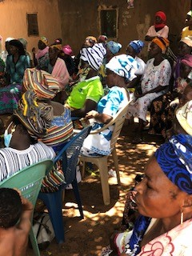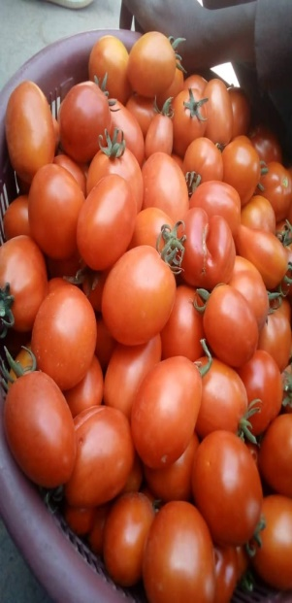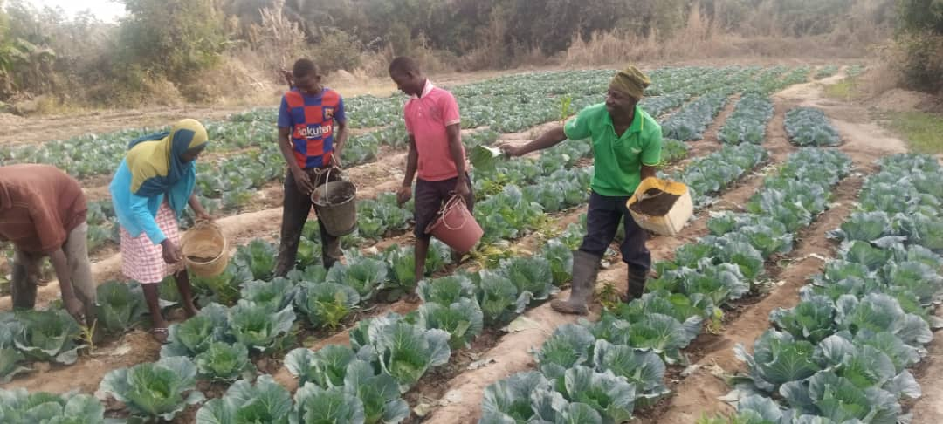

ANNUAL REPORT-DECEMBER 2021

To

GOAP/ELPG AND OTHERS

Organic Education for Farmers (OE4F) through F2FE Approach in the mist of COVID 19 Impacts

This work is being undertaken by the Ghana Organic Agriculture Project (GOAP) in collaboration with a local partner NGO, the Centre for Ecological Agriculture and Livelihoods (CEAL), located in Walewale, North East Region of Ghana.

Report by CEAL Team
Walewale,
INTRODUCTION
This is a summary but content packed report of all activities executed in 2021. The reports looks at what was planned, implemented, results, lessons and challenges during implementation in relation to project by project. CEAL is a local a NGO that works with small holder farmers to improve their local farming techniques for improved crop yields and other livelihoods in poor communities. CEAL project activities are largely supported by GOAP/ELPG, a partner NGO in the Netherlands. Other development partners who supported CEAL activities in 2021 are HSF-Kenya, GEF-SGP and ACDEP-Ghana. Using community landscape development approach, all CEAL project activities are purposely designed to achieve two cardinal objectives:
- To increase communities’ resilience to climate change particularly of women and other vulnerable groups in society
- To better strengthen the capacity of small holder farmers to adequately response to the looping dangers of food insecurity which is likely to result from outbreak of Corona virus in the West Mamprusi Municipality and beyond

Key project activities planned and executed during this reporting year 2021 include:
- Organic Education for Farmers (OE4F)’ using Farmer to Farmer Extension (F2FE) approach
- Promotion of Agro-forestry models among Smallholder Farmers(SHFs)
- Emergency Food AID for poor and affected households
- Small scale Drip irrigation project (3SIF Project)
- The project SULCi-FaNs: Scaling-Up Local Capacities to Innovate for Food and Nutrition Security
- South-South Cooperation Project- Replicating and Promoting broader adoption of innovative climate-smart agroecology within community landscapes in Ghana, Liberia, and Sierra Leone
- Gundoo Project Activities

A total of 27 vulnerable communities were covered under the project implementation. 10 communities were relatively new communities whiles the remaining 10 communities are coming from Zasilari old communities. The relatively 10 new communities are: Gbeduri, Kpabgu, Kata, Diyani, Nayogu, Korogu, Kukua, Kparigu, Boayini and Kperiga. The old communities are Bugya, Tinkaya, Binduri, Zangua, Wungu, Zangum, Boayini, Sagadugu, Guakudow and Zangum. Others include Kobori, Yama, winkogo, Sunbrugu, Nyariga, kpasemkpe, and Sayoo.

A total of 4756 farmers were covered as against estimated project farmer target population of 11,000. Out of this, 2987 farmers covered are male farmers whiles 1,769 are female farmers. The major organic measures promoted among the small holder farmers are fast developing compost preparation, and its application, tree planting, Biochair making, livestock management, fish farming, local innovation development and bee-keeping

DETAILED REPORTS
CEAL through ELGP/GOAP and other development partners, worked with a number of smallholder farmers especially youth and women to improve food, nutrition and income situation in West Mamprusi Municipal, This was achieved through a number of project activities:

SMALL SCALE DRIP IRRIGATION PROJECT (3SIF PROJECT)
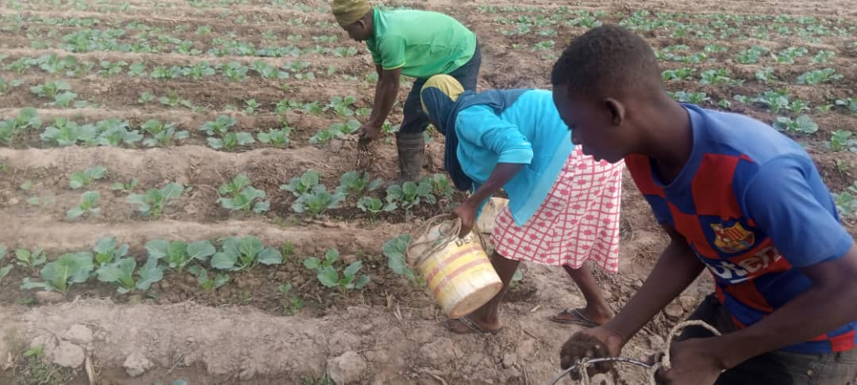
It is becoming increasingly difficult for the smallholder farmer (SHF) in northern Ghana to rely solely on rain-fed seasonal farming for household food security due to changes in climate and rainfall patterns. The five northern regions experience one short rainfall season in a year with prolong dry season starting from October to May the following year. The short rainfall season comes unpredicted with dire consequences of droughts and floods in most cases. To overcome these challenges, a number of smallholder farmers totaling 15SHFs and their families were selected in this reporting year 2021 to benefits from Small Scale Drip Irrigation Facilities to enable them produce food and livestock throughout the year. See the table below for details of beneficiaries:
Names, gender and location of beneficiaries
No. | Beneficiary | Gender | Location
1 | Musah Agoo | M | Sumbrungu
2 | Ayamga Anyama | F | Nyariga 1
3 | Daniel Anamsakiya | M | Nyariga 1
4 | Sadia Wuntima | F | Tinkpanga
5 | Dayugu Ali | M | Kabasi
6 | Bukari Takora | M | Kabasi
7 | Guma Eunice | F | Sayoo
8 | Ayamga Abosouri | M | Winkogo
9 | Ayamga A. Thomas | M | Nyariga 2
10 | Abdualai Asuah | M | Nyariga 2
11 | Humu Abdulai | F | Nyariga 2
12 | Yamusah Mustapha Sandow | M | Yama
13 | Sali Amidu | M | Yama
14 | Mahama Yakubu | M | Kpasenkpe
15 | Dahamatu Yussif | F | Kperiga
Drilling, Solar Pump, Tank and Drip lines installations-using a set of baseline criteria, the project carefully selected 15 farmers with suitable sites, conducted a geo-physical surveys to identify underground water sources.
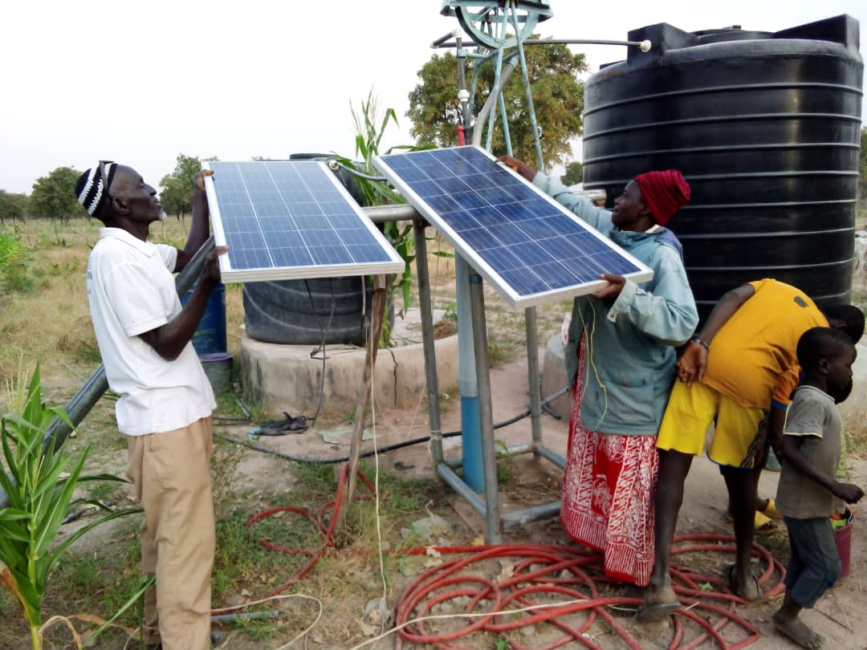
This was then followed with drilling and installations of boreholes, solar mechanized pumps and drip lines installation. This enabled beneficiaries to have access to water throughout the year for vegetable cultivations and also for household consumption. With these facilities, a total of 1,055,000.00 liters of water expected to be yielded by the 15 boreholes according my colleaque from Pump is Life. Out of this, Household Water Consumption is 261,300 liters while Drip irrigation consumption is 793,700 liters. This quantifies are then used in the cultivation of vegetables such as tomato, okra, onion, and other leafy vegetables.

Small size vegetable gardens-following the installations, beneficiaries are supported to construct small size vegetable garden for the production of vegetables and other household consuming crops.
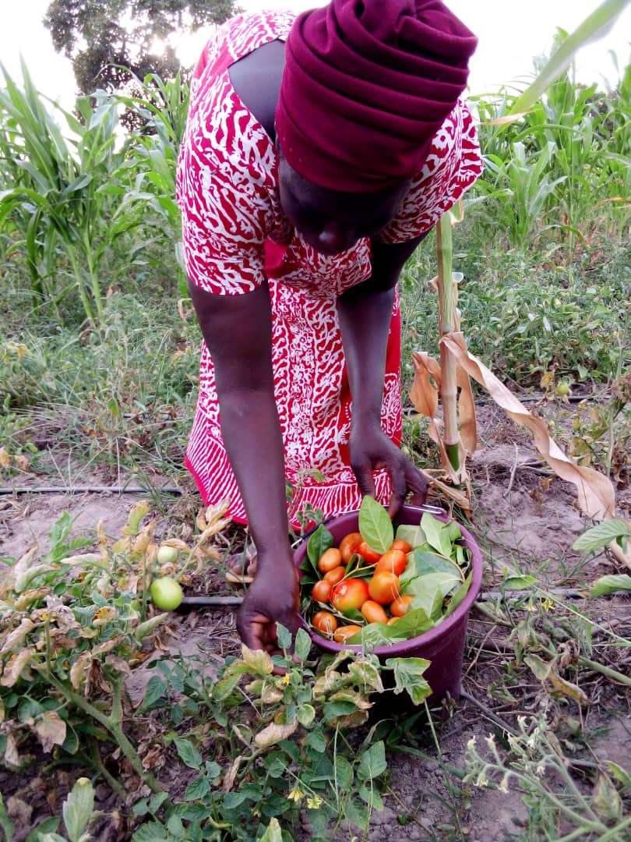
A total of 15 out of 15 have been constructed. With this facility, famers and their families received training in vegetable production. The beneficiaries are trained in basic skills in vegetable seed nurseries, types of nurseries, watering regimes, manure preparation and applications, transplanting, harvesting and marketing. A total of 36(19M: 17F) famers are trained with their family members to take care of their vegetable gardens. The farmers are trained to stagger production with market in mind in order to avoid glut and lower prices.

Farm input and implements supplied - the following farm implements are procured and distributed to the beneficiary farmers to apply during vegetable production - Spade, Cutlass, Shovel, Pickaxe, Wheel barrow, Wellington booth , Rakes, Polypots, watering Cans, Head pans, Knap sack spraying machines, Measuring types, Gloves and Ropes
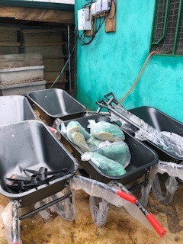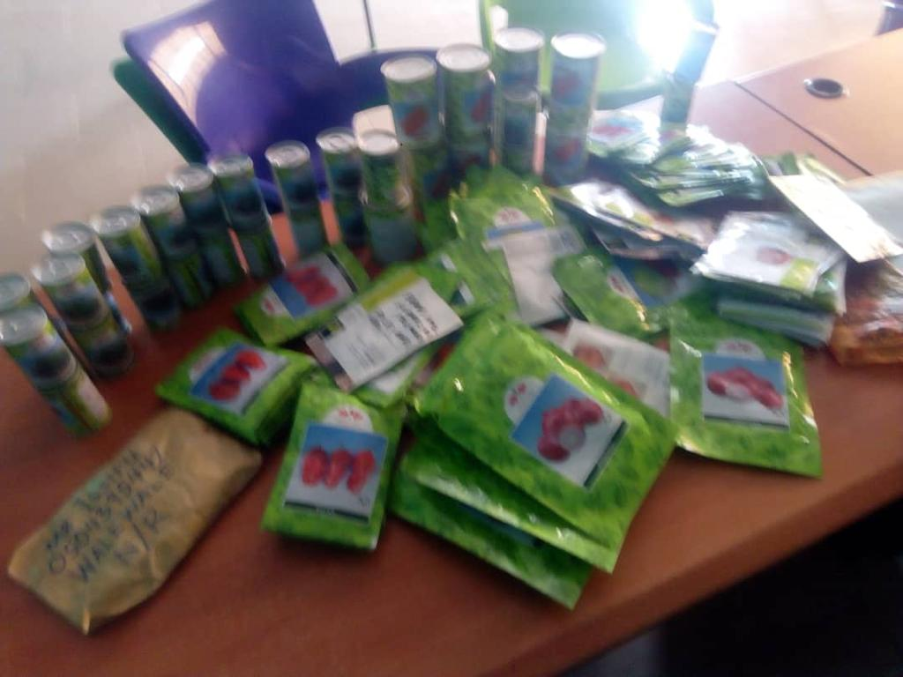
Farm inputs- the following farm inputs are procured and distributed to the beneficiary farmers to apply during vegetable production- Vegetable Improved seed varieties –onions, pepper, tomato, okra, Cashew improved seeds –polyclonal; Cowpea improved seeds, Banana suckers, coconut and grafted mangos

Agro–forestry- farmer plantations establishment- this component of the project activities supported the beneficiary farmers to establish their own plantations under multiple agro-forestry models depending on the availability of lands and the customary land tenure system of a particular area.
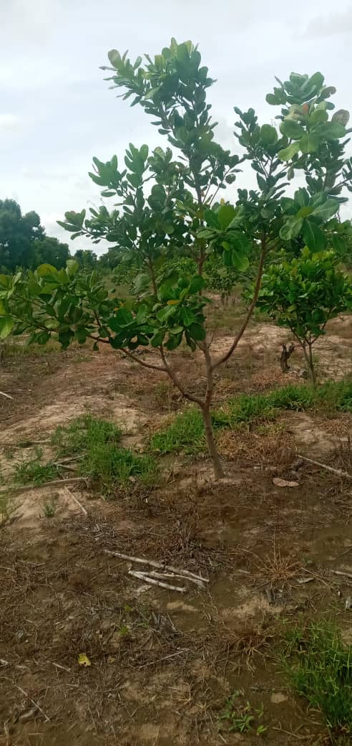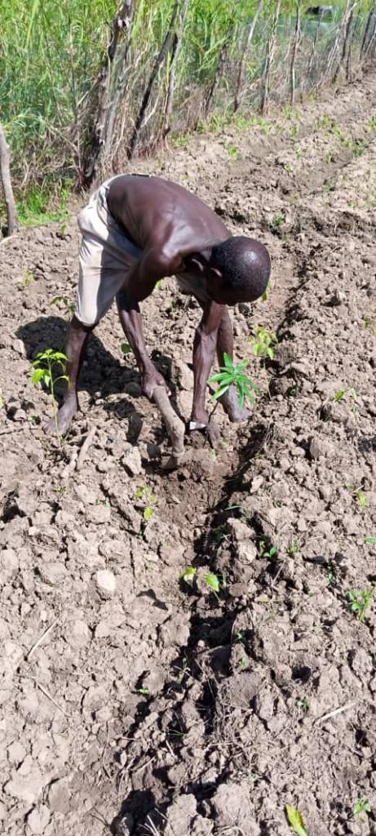
A total of 23 acres were planned and planted with 13 beneficiary farmers. Farmers and their families received trainings in seedlings raising, watering, planting and bushfire preventions. This enabled the beneficiary famers to produce and plant a total of 2040 seedlings for the year ended 2021. Seedlings raised and planted include cashew, mangos and cassia. Meanwhile monitoring 2020 plantation showed a remarkable results as some of the cashew are now standing 1-3 meters tall.

Livestock housing and management support – farmers totaling 15 received various support during this year 2021 under review as part of the small drip irrigation project implementation. Fifteen (15) farmers were trained and supported to operate 15 animal pens with poultry (local fowl and guinea fowl) and livestock (sheep and goat). Livestock production component was deliberate part of the project designed to enable farmers generate animal droppings to improve their soil fertility, produce meat to support household protein needs whiles maintaining considerable economic income from the sale of animals to cater for other household expenses. Therefore 15 beneficiary farmers received training in the areas of livestock housing construction, types, and the ideal conditions for different types of animals, livestock feeding and feed formulation, livestock disease control. Trainings was conducted with the help MOFA staff as resources persons. The beneficiaries are profiled into two groups ie those who have livestock but required housing support and those who have animal pen but required little modification and animals as start up support. A total of 9 beneficiaries had enough livestock and therefore received training skills and housing support to enable them keep their animals whiles the remaining 6 farmers had animal pens with no livestock and therefore were supported with livestock such as goats, guinea fowls together training skills. To ensure project sustainability and broad family participation, each farmer entire household were trained usually involving husband, wives, children and brothers and sisters of the husband family. A total of 56 household members participated, Out of this, 35 are male farmers whiles 21 are female farmers.
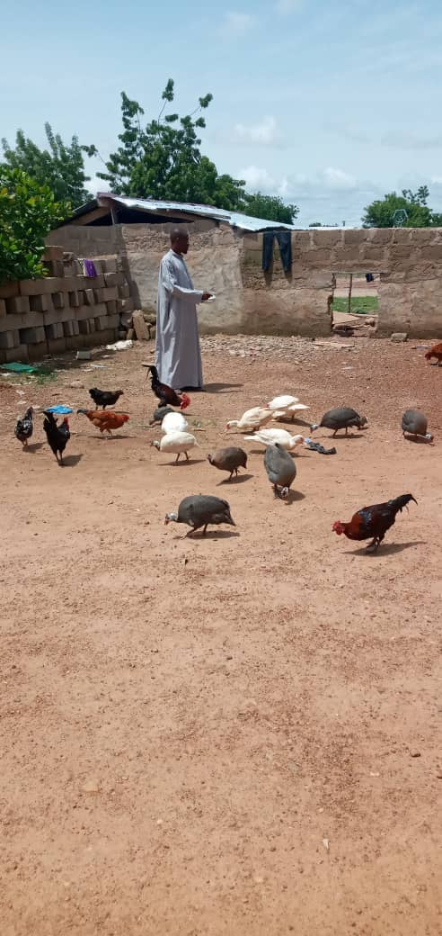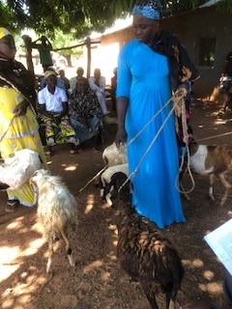

Business management activities- farmers totaling 15 and their family members are covered under this activity, as part of the project implementation. The 15 beneficiary farmers and their immediate family members received simple entrepreneurship and business management skill. CEAL in collaboration with Pump is life conducted training to the farmers.
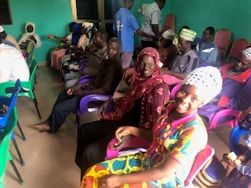
Farmers and their families were taken through the principles of good business establishment, ways of growing small scale business, types of business, how to raise capital and other resource mobilization as start-ups, others include accounts set up, types of banks accounts available for small scale business, advantages and disadvantages. A total of 63 household members participated, Out of this, 37 are male farmers whiles 26 are female farmers. In order to facilitate farmers’ access to micro credits, the 15 farmers have been supported to open their accounts and will be supported soon to access funds using special designed Microcredit applications forms
FARMER TO FARMER EXTENSION (F2FE) PROJECT:
This project forms the bedrock of CEAL agro eco farming activities in the West Mamprusi Municipal. The activity focuses on supporting small holder farmers to improve local farming techniques especially soil amendments for improved crop yields. Food insecurity in Northern Ghana is largely driven by weak and poor soils due to bad farming practices, climate change and in recent times, the ultimate distortion of basic farm inputs supply resulting from COVID 19 outbreak.
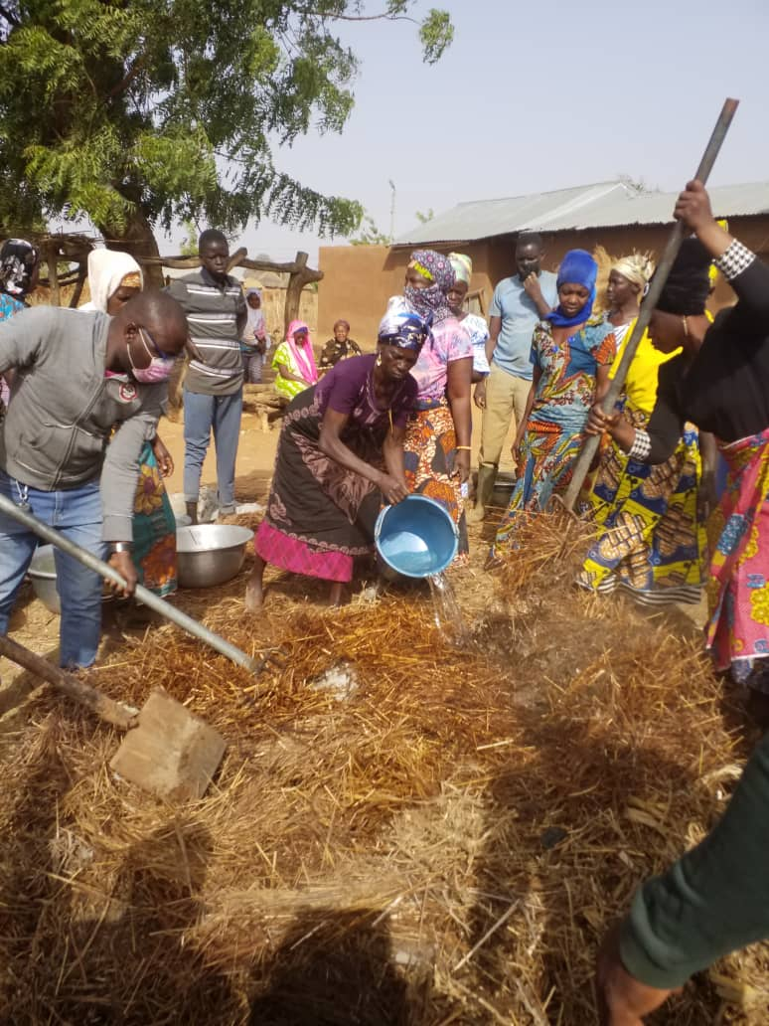
Improving soil condition is the most critical measure in food production system in West Mamprusi Municipal. Farmer to Farmer Extension (F2FE) approach was chosen and implemented 2 years ago due to its effectiveness in reaching out to as many farmers as possible within the shortest possible time in the face of COVID 19 outbreak. The project activity is supported by GOAP/ELPG, a strategic partner NGO in the Netherlands.
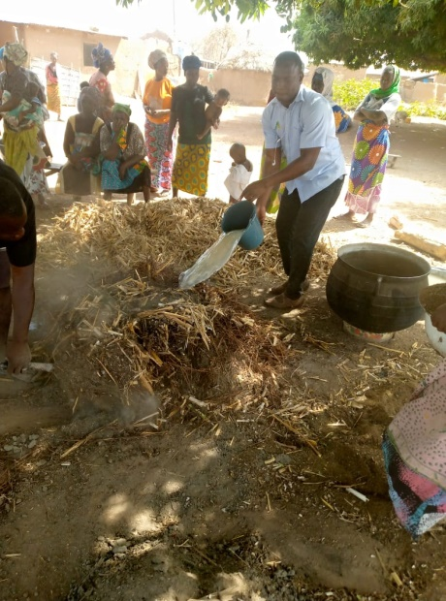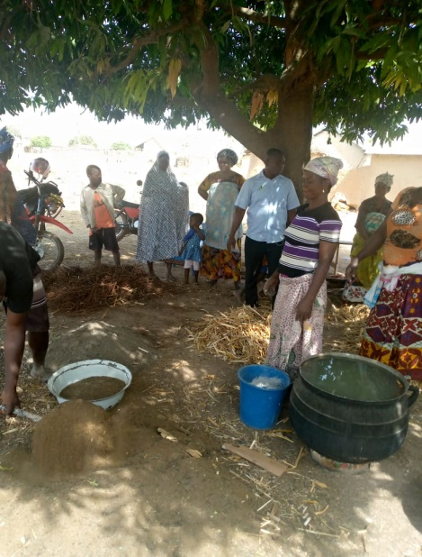
The activity is aimed at strengthening the capacity of farmers to adequately response to the looping dangers of food insecurity which is likely to result from outbreak of Corona virus in the West Mamprusi Municipality and beyond. A total of 20 vulnerable communities are covered under the project implementation with the following series of activities and community level actions:
Compost Making Activities
Skill development in compost building was provided to a larger of number of smallholder farmers through F2F during the year 2021 under review.
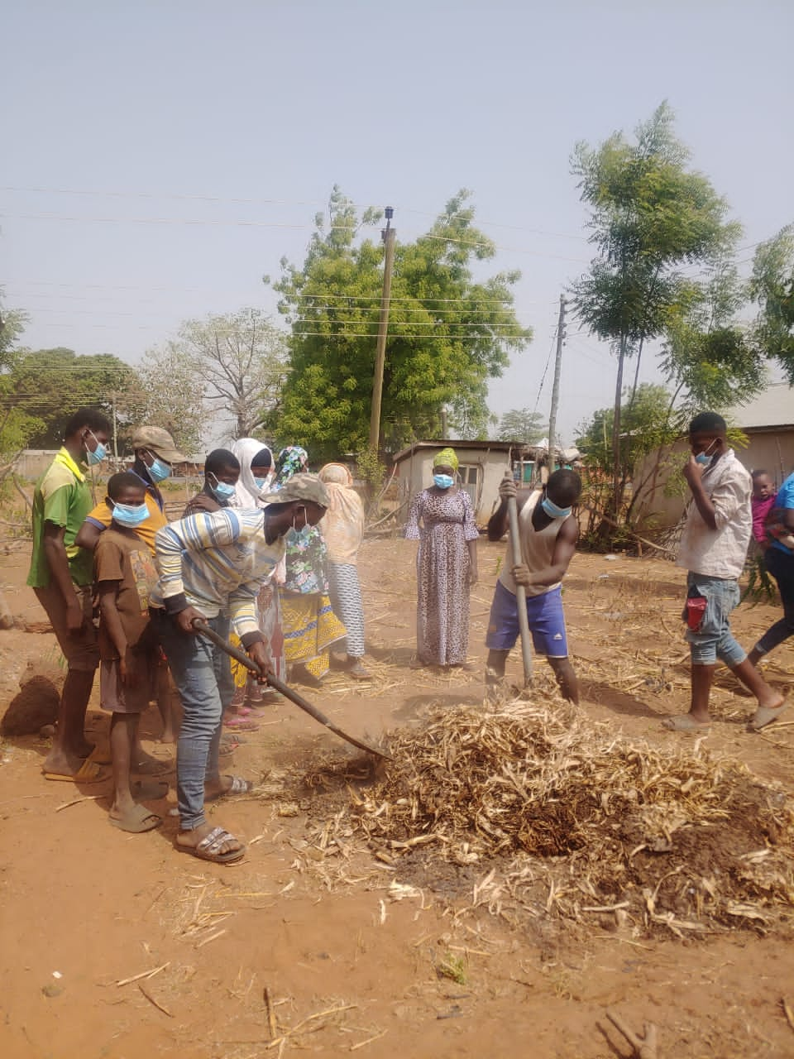
This specific activity is a yearly routine and continues with the current one being the 4th phases as part of the broader strategy to cover more farmers within the shortest possible time. The activity came in the form of a 6-weeks composting skills and knowledge as part of providing quicker solution to vulnerable farmers to overcome poor soil conditions. Following the successful implementation of the 1st, 2nd, and 3rd phases of the project activity, where step down trainings of the 10 lead farmers training 10 each (10x10= 100).
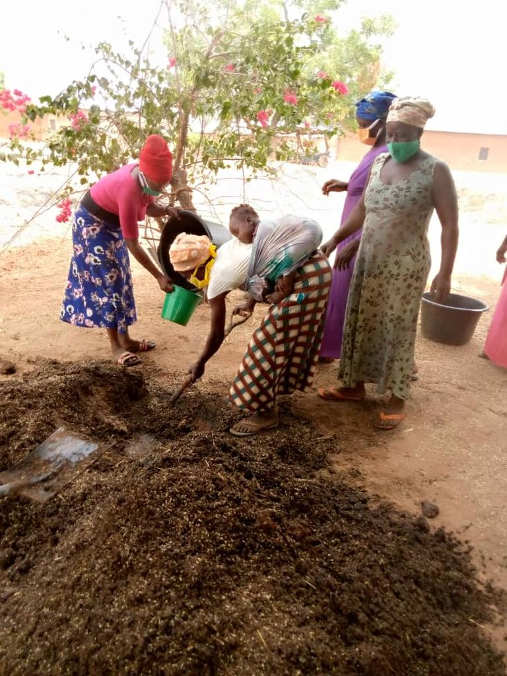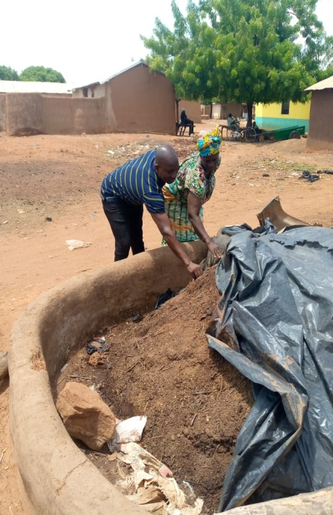
The 100 farmers also training 10 each (100x10=1000), the 4th phases was earmarked to support the 1000 farmers to train 10 each (1000x10 =10,000) in the relatively 10 new communities. Using similar but a modified F2F approach, another 10 lead community compost experts were required to train 100 each of their colleague farmers ie 10x100=1000 in old 10 ZEFP communities to meet a target of 11,000 farmers’ population in 20 communities. With this target, a total of 4756 small holder farmers received training and supported by their colleagues to practice and build compost of varying sizes and quantities. Out of this, 2987 farmers covered are male farmers whiles 1,769 are female farmers. With the well-established compost building training standards, procedures and materials, the farmers were trained and encouraged to build their own compost by their colleagues with CEAL organic farming experts playing only facilitation and supervisory roles. Front line farmers received refresher training in a participatory manner with joint facilitation from officers of CEAL and Municipal Department of Food and Agriculture, Walewale. With technical advice from Prof kwebena Ofosu-Budu, University Ghana, expert in composting, farmers were carefully selected using a set of criteria such as urgent need/poor, willingness to practice, the commitment to train and supervise colleague smallholder farmer to practice and duplicate technology.
The farmers were then trained to combine and use Materials mainly from plant and animal sources which are readily available in our communities. These materials were group according to the essential plant nutrients of N.P.K. Using different dimensions according to farmer strengths and capabilities, a combination of droppings from poultry, pigs, goats, sheep, cow dung with Ashes, remains of Maize, millets, sorghum, Soya beans, rice, groundnuts and grasses of different categories were carefully put together to prepare a very rich and fast developing compost. This compost prepared are turned weekly with water for the next 6 weeks to produce fully decomposed compost under carefully prepared atmospheric condition into plant nutrition for application. During farmer-led trainings, farmers were advised to conduct their compost building activities strictly under COVID 19 Precaution Protocols. In addition, the farmers were trained in preparing soil nutrition from household waste and dump sites degradable material as a rapid response in meeting their soil nutritional requirement for the season.
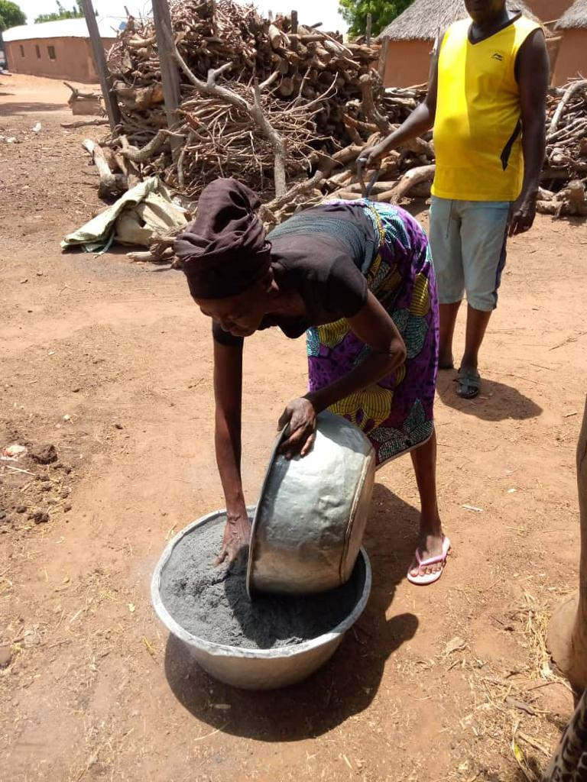
The farmers who came from the relatively 10 new communities are Gbeduri, Kpabgu, Kata, Diyani, Nayogu, korogu, Kukua, Kparigu, Boayini and Kperiga. Other farmers who came from 10 old Zasilari communities are Bugya, Tinkaya, Binduri, Zangua, Wungu, Zangum, Boayini, Sagadugu, Guakudow and Zangu. The old ZEFP communities have some considerable knowledge and skills in compost making under previous Zasilari programs and therefore required refresher and new, fast developing compost building (6-Weeks Composting) and application technology to improve their resilience in this difficult era of COVID 19 outbreak. Each farmer gathers his or her compost building materials, registered 10 Smallholder Famers and then conducted the training. The training and compost preparation practicing continued until farmers started tilling, sowing and application of their soil nutrition substances.
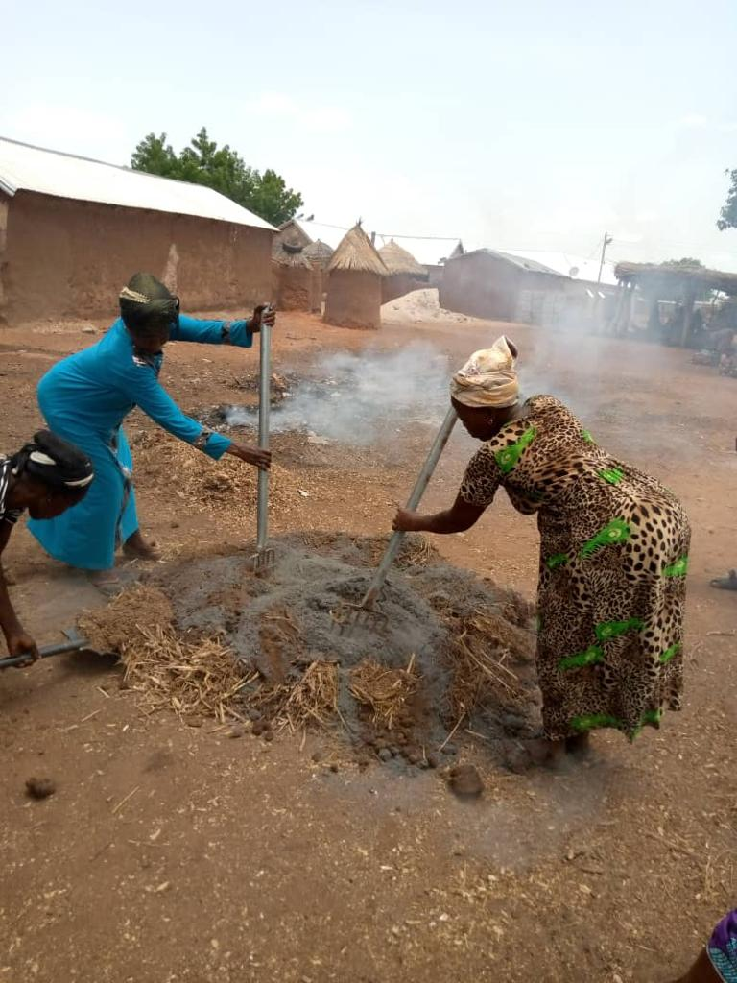
Field officers together with lead farmers already trained closely monitor each of the farmers to make sure that enough materials are gathered for the preparation of individual compost. Supervising each of the farmer became a bit challenged as farmers’ number begum to increase.
Compost Application skill and knowledge shared
It’s been observed over the years that the poor rural farmer’s yield depends strongly on how efficient his/her compost materials are applied on piece of farmland.
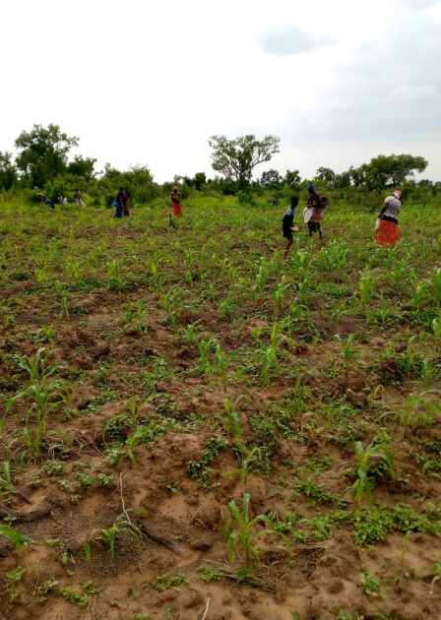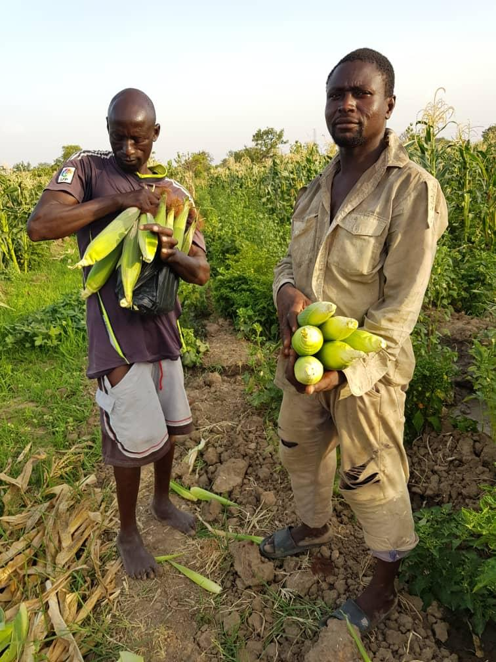
The more effectively compost is applied the better the yield. For that reason, compost application skill was given to selected farmers under the F2F approach. A total of 1756 was covered under this activity. Out of this 985 were male farmers whiles 771 were female farmers according our records. This activity was undertaken to train farmers on the effective compost application techniques. The activity came in the form of on-farm trainings using farmer to farmer approach. First 40 lead farmers received trainings in Site Placement Skills where a hole is dug or a circle is made around the crop and fully decompose compost is placed direct to ensure direct and effective absorption of the plant nutrient. The 40 lead farmers then proceed to train their colleagues/same smallholder farmers along the line of F2FE approach
Few challenges –difficult tracking and recording farmer numbers as more and more farmers are trained by their colleagues. In addition, farm implement and tools became inadequate to meet demand of the soaring numbers of farmers trained in the downstream under F2F. Other challenges include lack of transport and water scarcity especially in the hot season as more and more farmers joined to build compost in the communities
Results/ achievements
Despite the challenges of tracking larger farmer numbers, a total of 4670 (M2987: F1,769) were reached out, trained and supported through F2F to build substantial of number of piles and pit compost in the communities with remarkable results. With the limited but necessary and basic compost building farm implements and materials, a total of 4123 pile and pit compost were constructed with varying compost building dimensions. Out of this, 1,891 of the compost built were by women whiles the rest came from men ie 2.232.
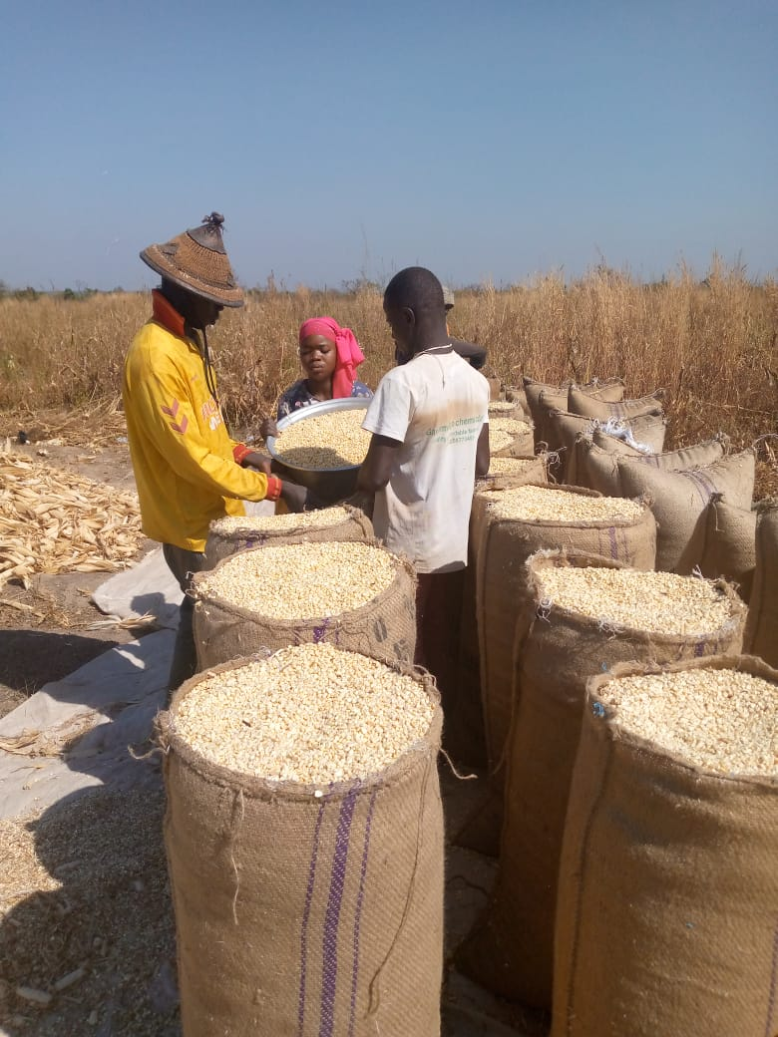
With this support, farmers were able to prepare considerable quantities of plant nutrition for the year 2021 farming season uses in their various communities. It may interest readers of this report to note that a serious chemical fertilizer shortages occurred in 2021 farming season and farmers who took CEAL F2F activities serious were the winners as they had very little to worry about as they were not affected negatively at all by the shortages because they had fully prepared with plant nutrition substances from their compost heaps and did not need to relied on government chemical fertilizers to improve their soil conditions.
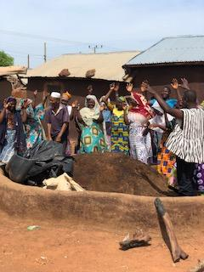
Through this activity the smallholder farmer is able to improve their soils fertility, reduce cost per acres from purchase of chemical fertilizers, and thereby increase their maize yields from average of 4 bags to 8-12 bags/acre. The smallholder farmer benefiting from F2F invest their energy and time in building rich compost and its application in the cultivation of organic maize, millet, beans varieties and vegetables for both incomes and household food consumption. A visit to Nayogu, Mma Nantoma, a local beneficiary middle age female farmer had this to say ‘its reliable and cheaper to make, the raw material are available here in our communities, one don’t need to wait for government once you are hardworking, you should be able to make your own compost see see see, I have 8 bags(100hk) of maize from my 1acre compost application farm. I will be able to feed my family until next farming season
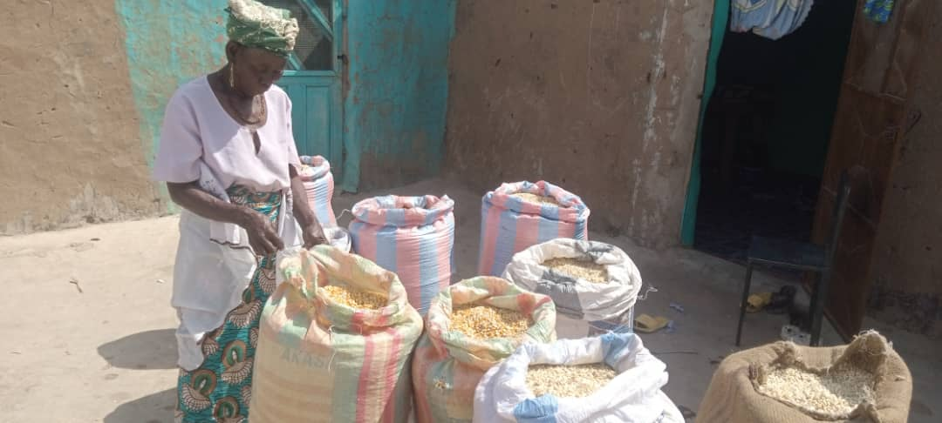
Best Compost Farmers Received Awards
As part of 2021 achievements, 9 outstanding farmers from F2F communities received awards in recognition of their contribution to promoting food security in their communities. Farmer’s day is cerebrated every year in December to honor our hardworking farmers in Ghana for their contribution to nation building. As such the following F2F individuals were awarded
Name | Sex | Community | Awards
Osman Furu | M | Kparigu | Certs, farm implements
Bora Tia | M | Guabuliga | Certs, farm implements
Sadia Issifu | F | Gbani/Kpabgu | Certs, farm implements
David Zandow | M | Zangum | Certs, farm implements
Asana Wuni | F | Tinguri/Gbeduri | Certs, farm implements
Zaratu Seidu | F | Kata | Certs, farm implements
Rahinatu Issifu | F | Kukua | Certs, farm implements
Ishia Muniru | F | Nayogu | Certs, farm implements
Raffia Sulley | F | Kurugu | Certs, farm implements
The event was organized by Municipal Department of Food and Agriculture on behalf of Government of Ghana. The farmer’s day comes once every year and usually takes place on the first Friday of every December.
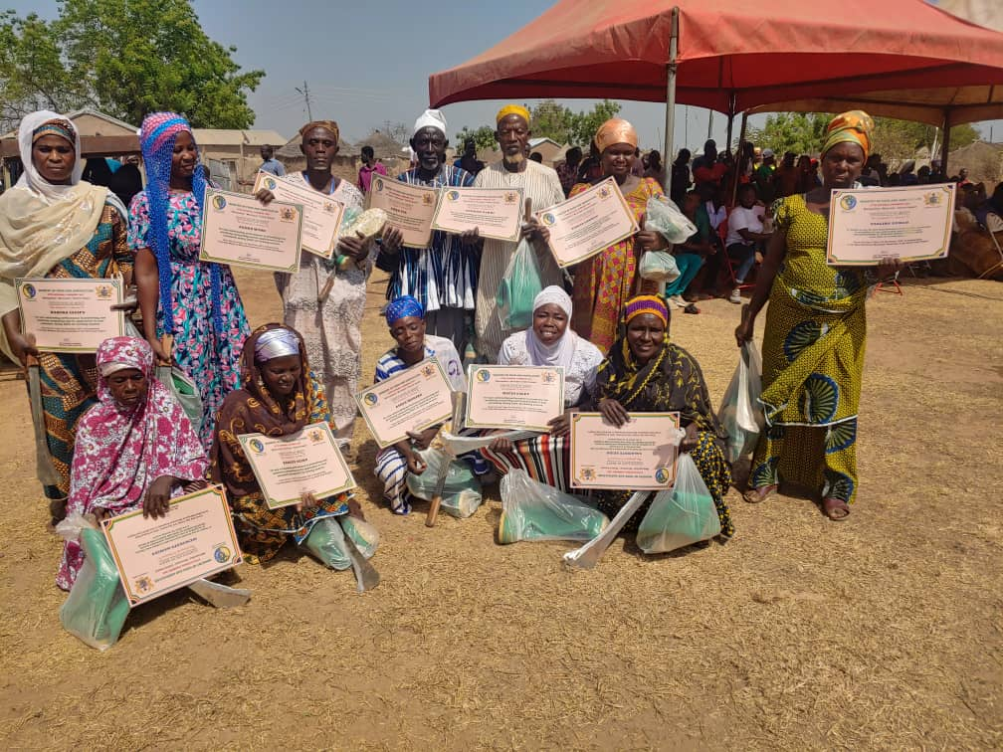
The 2021 farmer’s day celebration took place on Friday, 3rd December in Kpasemkpe, a relatively small but very busy farming and fishing community along the White Volta in the West Mamprusi Municipal. The community was selected because of its strategic importance in food production in the Municipal. The event has basically the objectives of honoring our farmers as heros, recognizing their contribution to nation building; motivating hardworking winning farmers to do more whiles encouraging others farmers to work hard so that they too could be recognized in the next farming season. Due to its prominence and competiveness, winners are selected through a vigorous municipal-wide assessment by 11 member multi-stakeholder committee put in place by the Municipal Assembly (Local Authority).
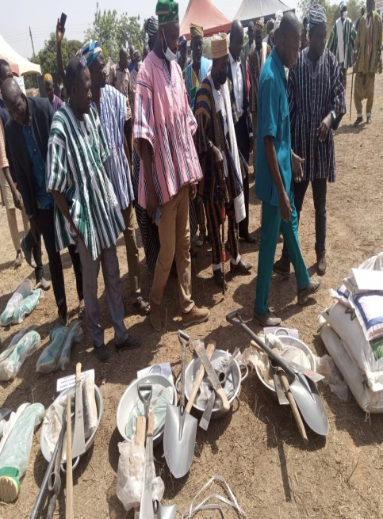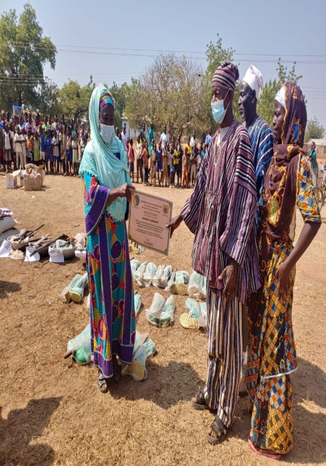
The committee assessed farmers on different categories through interviews, physical examinations of their farm activities, records, yields and community impacts/influence, and then come out with the list of winners for the awards. The 9 farmers were awarded with simple farm implements such as cutlass, wellington booths, spades, water basins and certificate of recognition.
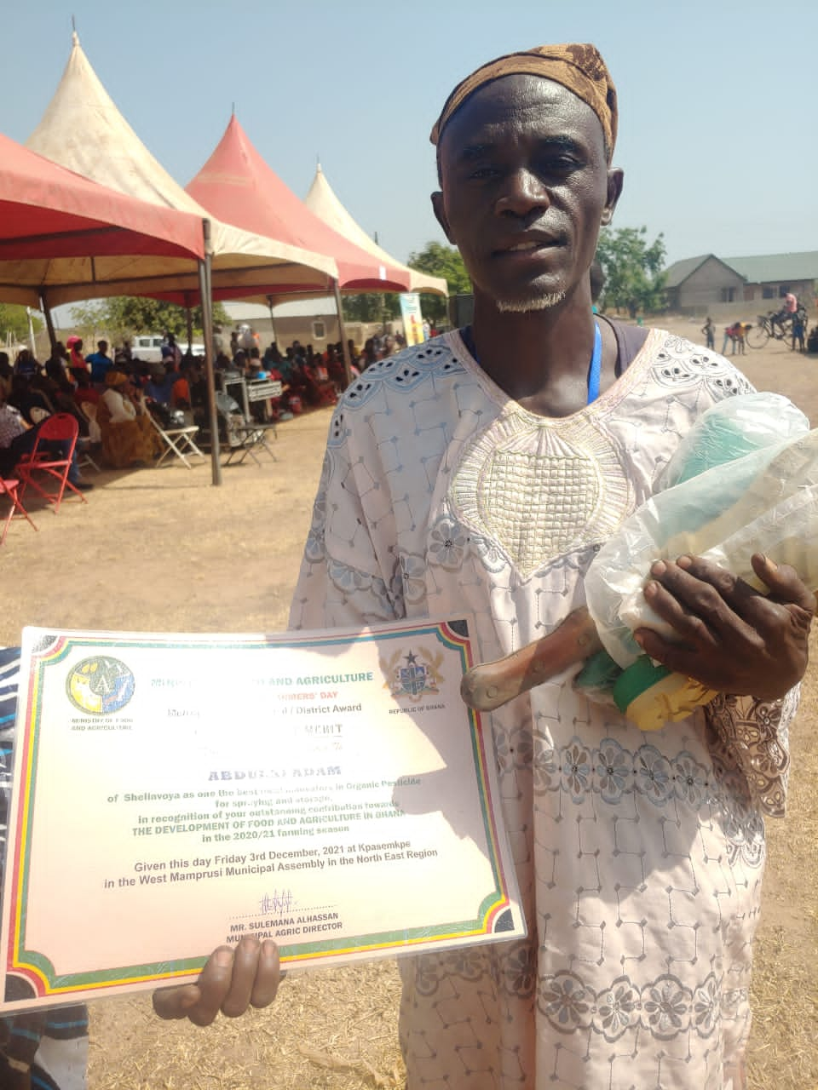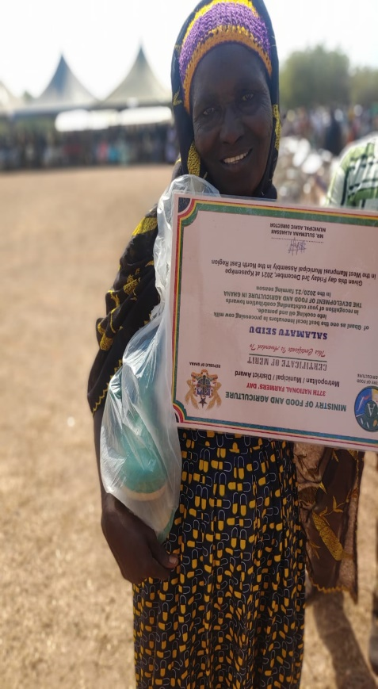
These awards will enable them to continue practicing composting, and effect change as they continue to encourage their colleague farmers to practice compost making and sustainable agro ecology in their communities.

AGRO-FORESTRY MODELS PROMOTION
Series of activities in seedling multiplication and plantation development were implemented in general during the year 2021 under review. Notable among them include:
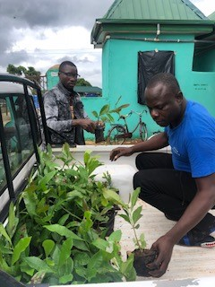
Nursery establishment –using CEAL farmer training center facility, a total of 5670 seedlings were raised for distribution to a number of smallholder farmer practicing different model of agro-forestry scheme. Seedlings include Cashiew, like Albizia, Leucaenia and Acacia. The facility allowed CEAL to raise enough seedlings and distributed to small holder farmers under the CEAL agro-forestry model support. They are planted to provide protection, covers, soil improvement and animal feed to livestock as immediate benefits to the farmer.
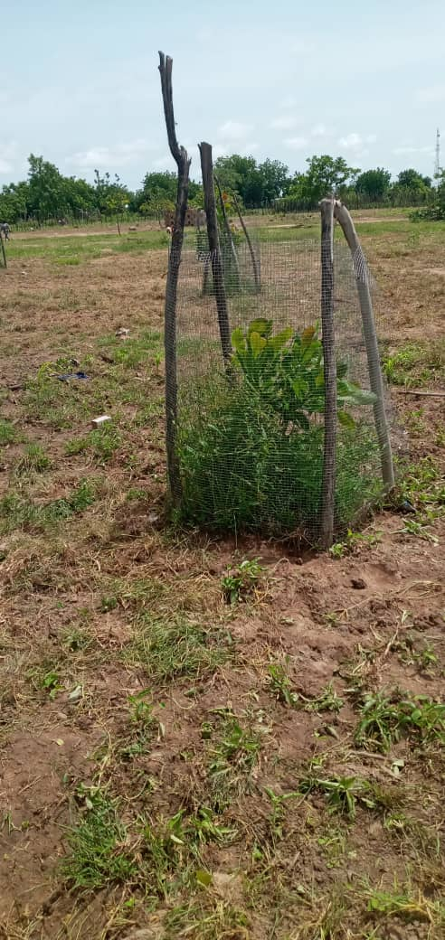
Training and support To Tree Planting- farmers who received seedlings also got training in tree planting to enable them plant their seedlings. They were trained in seedling handlings, planting and tree protection against bushfires and animals. This activity followed immediately after seedlings distribution to farmers. As part of the CEAL broader activities, 3 types of agro forestry are promoted. Smallholder farmers are trained to integrate tree seedlings into their agriculture farming systems as part of the long term strategy for both income and food security. The agro forestry models allowed the stallholder farmers the flexibility of adding and integrating relevant tree of her/his choses in manner that allows the farmer to continue cultivating food crops. Depending on the availability of lands, the land tenure system of a particular location, socio-cultural and gender dynamics, a model is discussed and implemented with a group of farmers. A total of 234 smallholder farmers were covered under this activity. Out of this, 201 of them are male farmers whiles 33 are female farmers across the region. In addition, 56 farmers are new farmers’ whiles 178 are old farmers who only received seedlings to beat-up their fields.
Few challenges during implementation –threats from Fulani herdsmen and also stray animals from communities posed a serious threat to the growth of trees planted. A number of cashew plantations and other tree species were destroyed triggering fighting between the owners of livestock and tree plantation, CEAL had advised tree owner to plan few so that they are able to provide protection instead of large unprotected
SOUTH-SOUTH COOPERATION PROJECT -Replicating And Promoting Broader Adoption Of Innovative Climate-Smart Agroecology Within Community Landscapes In Ghana, Liberia, And Sierra Leone.
This is a knowledge sharing project in agro ecology innovations among smallholder farmers in three countries –namely Liberia, Sierra Leon and Ghana. The activity is aimed at promoting inter and intra agro-ecology innovative technologies and skills transfer within the three West Africa Countries. Components of the project activities are implement by three local NGOs namely:
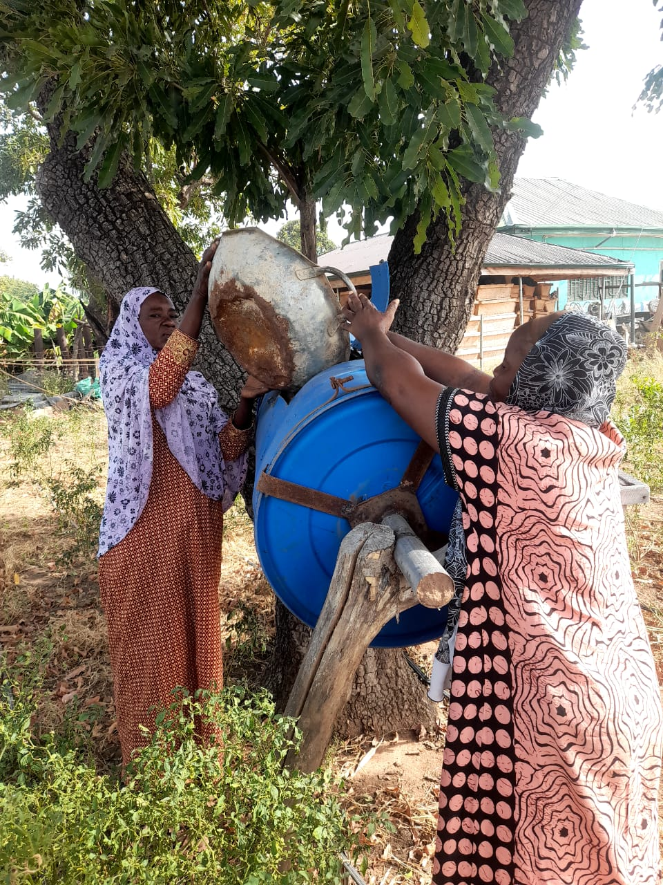
Center For Ecological Agriculture and Livelihood (CEAL-Ghana) focusing on promoting Integrated organic farming approaches: skill and technology development transfer: Liberia Endangered Species Association (LESA-Liberia) concentrating on Revival of traditional agro ecology Vs industrial agricultural eg. Seed protection/ sovereignty whiles Serve Sierra Leon (SSL-Sierra Leon) worked on Sustainable biodiversity issues, organic farming techniques, agro/afforestation, livestock etc. CEAL activities started with the following:
Undertake Community Sensitization On The Project Objectives And Agro Ecology Principles - The project took steps to sensitize project implementing communities.
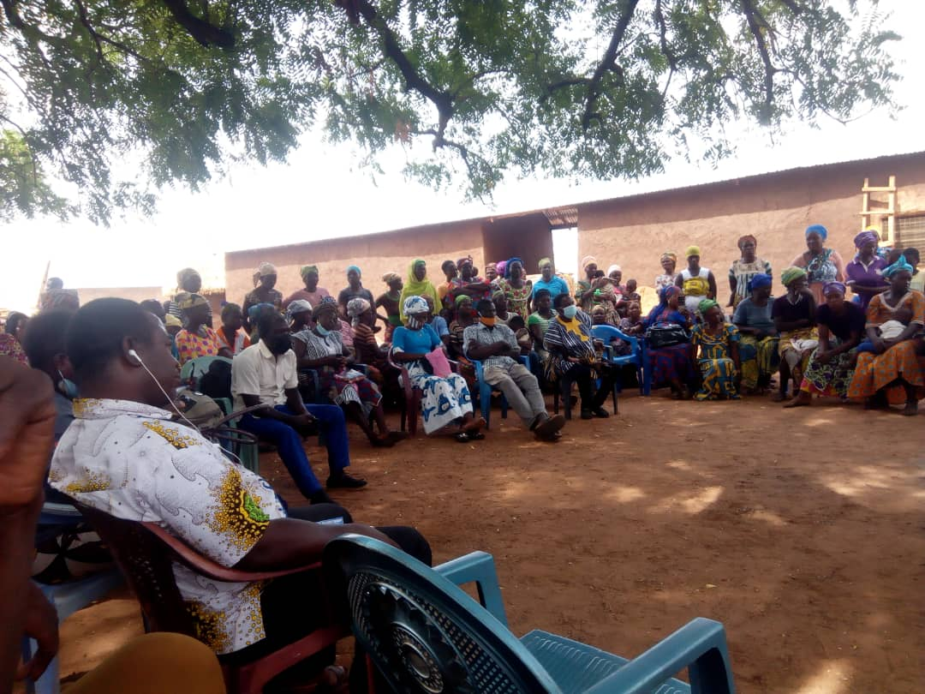
In all a total of 10 communities were visited and sensitized. The communities are Gbani, Tinguri, Gbeduri, Boayini, Sagadugu, Kata, Banawa, Gbimsi, kukua, and shelinvoya community. Farmers in the 10 communities were sensitized on the project objectives, what the project is seeking to achieve, outputs and project beneficiaries. Farmers were also educated on agro ecological measures, why the need to adopt and practice the agro ecology-farming systems, benefits including the long term advantages a farmers stands to gain if he or she stick to practicing agro-ecological farming principles. The activity was carried out by the project management team, a local consultant from local civil society organization and a MOFA officer in the West Mamprusi Municipal. A total of 956(402F:554M) individuals took part with different background mainly farmers, fishermen, traders, women, youth, men, hunters, charcoal producers, etc in the 10 communities.

150 Farmers Mobilized, Trained And Created A Network Of Agro Ecology Farmers-As part of project implementation, 150 farmers were carefully selected to create a network of farmers in agro ecology to benefit directly from series of agro ecological trainings and technological transfer. The network will work together to share and practices a agro ecological innovations, sustainable land management, conservation agriculture and climate smart agricultural practices. Out this 150, 64 are female farmers whiles the 86 are male farmers. The farmers were trained in group dynamics and networking facilitation, formation and management. This enables them to form and manage their network into functional one.

Train And Support Farmers With Aquoponic –Cropping Systems-As part of agro-ecology technology transfer, farmers totaling 149 received training and skills with experience or practical feelings in aquoponic –cropping systems.
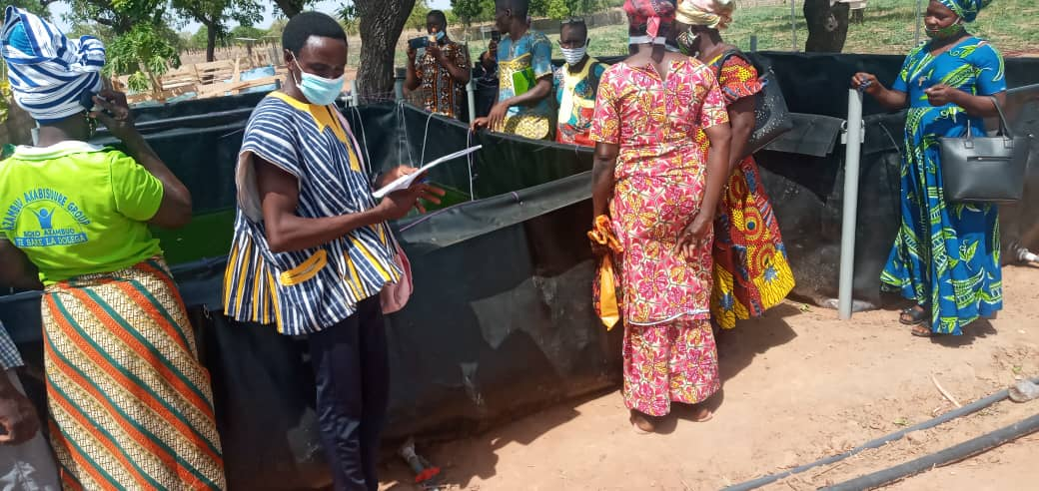
This was designed to influence the farming system of the new enterprising rural farmer to diversify and promote sound agro ecological farming system in their various communities. Out this total of 149 individuals, 64 are Female farmers whiles 85 are male farmers. During the training, farmers were made to understand and appreciate the importance of fish farming in the mist of climate change, process of fish farming, stocking, feeding, and how residue from fish farming could be connected to crop farming as folia fertilization. The activity was carried out by the CEAL project management team, a local consultant, fish training expert and MOFA officer in the West Mamprusi Municipal.
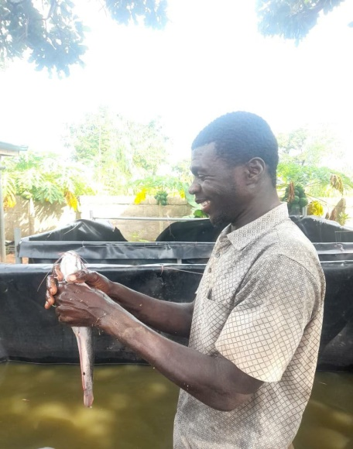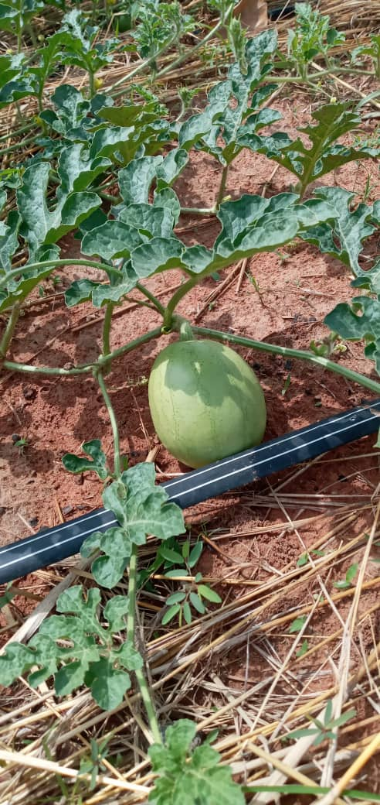
In participatory form, the training was conducted using both local languages and English language to enhance participants understanding of key themes. A total of 6 mobile fishponds were procured with a capacity of 500 fingerlings/pond. These ponds are installed and were used to aid the training in aquaponics. In addition, 12 ponds have been constructed using local craftsmen for distributions to few smallholders as pilot at the community level.

Train And Support Farmers To Access Biochair Processing Technology-As part of strengthening farmers capacity in agro ecology farming measures, a training workshop was organized by CEAL in organic farming mainly in boichair preparation. The training sought to build and strengthens the capacities of farmers in plant nutrition improvement as they transition into organic farmers in Ghana.
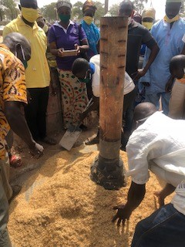
Already smallholder farmers in these communities received training in composting under the F2F and also under old ZEFP composting programs. Biochair is a soil conditioner
and has a potential to increase farmer’s yield if applied together with well-prepared compost. For that matter, the selected 149 farmers were trained to prepare their own Biochair.
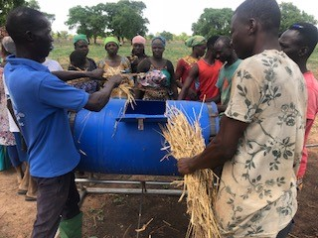
The activity Took Place in Walewale at the CEAL’s Training center. The training was conducted in collaboration with, Boichair development Experts and Members of MOFA staff. Out this total of 149 individuals, 64 are Female farmers whiles 85 are male farmers. As part from biocahir preparation, the farmers also received refresher training on how to improve their soil nutrient with compost making, cover crops, organic fertilizers and other soil nutrient improving techniques such as crop rotation, mulching etc. in addition two new compost building technologies are introduced to farmers using metal fabricated and tree branches stands with waste drums in the communities.

Train And Support Farmers With Local Innovative Bee-Keeping And Honey Making Technologies-Honey is widely consumed by community members but challenged by high cost of constructed wooden bee hives which are not highly colonized by bees, making bee keeping or honey production venture unattractive. An innovator is identified under project. This came to light during community sensitization of previous and current project implementations. The innovator called Mohammed Wuni is able to make a very cheap but highly efficient local bee-hives. The innovator addresses this challenge by constructing a local beehive (se-yuwa) with straw mats (Zana mats) and clay soil. To construct the ‘se-yuwa’ hive, the innovator uses local grasses to weave into Zana Mat. The mat is then folded into a cylindrical shape with the aid of sticks. A special clay is then prepared to plaster the inner part of the cylindrically –shaped mat. He then uses cow dung and eggs as attractive agents (baits) to get bees to colonize quickly. The combine effects of cow dung and eggs make the bee-hives get colonized faster as compared to the other traditional and modern hives, and are also very productive. By his innovation, the innovator is able to come out with easily constructed, cheaper bee-hives and avoid wild honey harvesting to improve the environment.
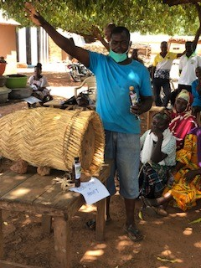
In addition, he is able to increase bee population, increase honey production to improve community nutrition whiles making economic income for his family. His innovation was quickly recognized, appreciated and identified for further development for broader adoption as part of the project implementation. For that matter first hand training, learning and sharing was organized for the 149 farmers to learn his innovation. This activity was facilitated by CEAL Team and Mofa staff in the municipal. In the end farmers were able to learn and share their knowledge and skills on the hive constructions.

Introduce Surface Runoff Rainwater Technologies-As part of project implementation, a number of simple but efficient surface run off rain water harvesting technologies have been introduced to support the rural farming service center in the Municipal. This enabled farmers to come and learn for broader adoption. Notable among include blocking of water ways and re-directing them to a common water collection center for use to be stored for future uses
Integrated Livestock-Cropping Systems-The idea of smallholder farmer managing livestock together with crop farming is not new in the West Mamprusi Area but the difference comes from how it is practiced. Most often the smallholder farmer managed his livestock separate from the cropping lands and therefore is unable to reap the full benefits of the livestock –cropping integration. This project activity sought to support the smallholder farmer to integrate fully both livestock and cropping mainly vegetables on the same piece of land so as to increase and enjoy the full benefits of livestock –cropping integration. The technology has the tendency of reducing and balancing risks associated with crop failure and livestock mortality in that the smallholder farmer has something to rely on if one component fails ie he/she has crops if livestock fails and vice versa.
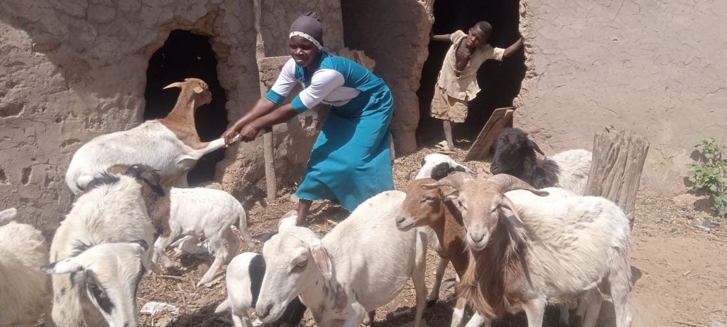
Currently 143 out of 150 project beneficiaries are trained in various aspect of this activity. In addition 46 non project beneficiaries also received training totaling 189 smallholder farmers. They are trained in basic livestock management, housing, feeding, disease control and furthermore on how to integrate through land demarcation, partition designs for both crops and livestock, positioning and crop-livestock compatibility all on the same piece of land. Currently a total of 6 women are piloting whiles the rest of the smallholder farmers are looking at the best way to put their skills into practice. Common livestock include Guinea fowls, local fowls, goats, piggery, and sheep. Common crops include vegetables such as pepper and watermelon. This activity is being looked at as small scale business enterprise. As an agri-business model, our team of expert’s train and equip farmers with skills and knowledge in livestock–crops integrations processes, Incubator construction/manufacturing. CEAL is developing small hatchery centers in local communities to promote quick access to day olds by the small holder farmer in the Northern Ghana. Additional technologies deployed under this activity are the mobile chicken pen that allows the farmers to rotating and fertilized poor soils directly on the same piece of land. Through this activity, 189 small holder farmers are able to multiply their livestock from average of 3 to 20n in the case of small remnants and 10 to 120 in the case of birds, given women and youth farmers the chance to make additional income to support other household choices.
Village Savings and Loan Schemes (VSLs)-an important component of the project implementation in that farmers especially women can be supported to safe and loan each other from their savings for the purposes of promoting and practicing their innovations in agro-ecology and organic farming to enhance food and income security in their local communities. This activity has the potentials of ensuring the long term project activity sustainability after the grant period. The farmers will have some considerable income from their saving to continue practicing their innovations after the project ends. For that reason, 120 farmers are trained and supported to form and operate their own Village Savings and Loans Groups in their communities. The smallholder farmers are trained in basic group management dynamics and supported to develop their own procedures of electing their executives, book/records keepings, constitution/group guiding principles and conflict resolutions procedures. This will enable the farmers to manage their groups effectively. In addition 4 groups who successfully completed their trainings received equipment support to enhance their Village Saving Schemes. The equipment include Note/records Books, Saving Pass Books, Metal Fabricated Money Savings Boxes and other writing materials to enable them save and keep records of the group activities. Although the activity is at its early stages but already making some differences as farmers were able to borrow during the latter of the farming season to hire labor in support of their farming activities.
Few Challenges during Implementation-Benefits/items distribution had been a problem because of the numbers of the smallholder farmers involved as against limited funds. Technologies such as rainwater harvesting equipment, fish ponds construction, animal pens etc are expensive as compared to an average cost of 1300Ghs/farmer expenditure that the project is willing to give ie without considering, overhead cost, With few made as against every farmer interested, it becomes difficult to distribute what is available. In addition the Integration process still has some challenges due incompatibility of some crop-livestock at a certain stages of implementation.
Few Ideas and Technologies Shared-the project after one year of implementation had organized two knowledge and ideas sharing for forums. The 2 forums organized came in the form of online due to the spread of COVID 19 in the West Africa Sub-region. The online forums provided a platform for each country to present and share their innovative activities for possible adoptions:
CEAL managed to set up the Rural Farmer Service Center, updated and developed it to give smallholder farmers access especially youth to agro-ecology farming skills, knowledge and other technology transfer in which Liberia and Sierra Leon Counterparts expressed interest in duplicating in their countries. CEAL also introduced to LESA and SSL, the idea of Aquaponic –Cropping Systems, Soil Amendments Technologies-such as Boichar preparation and application, Integrated livestock-Cropping systems and Local innovation Bee-keeping technologies to enable them pick and practice in the their countries.
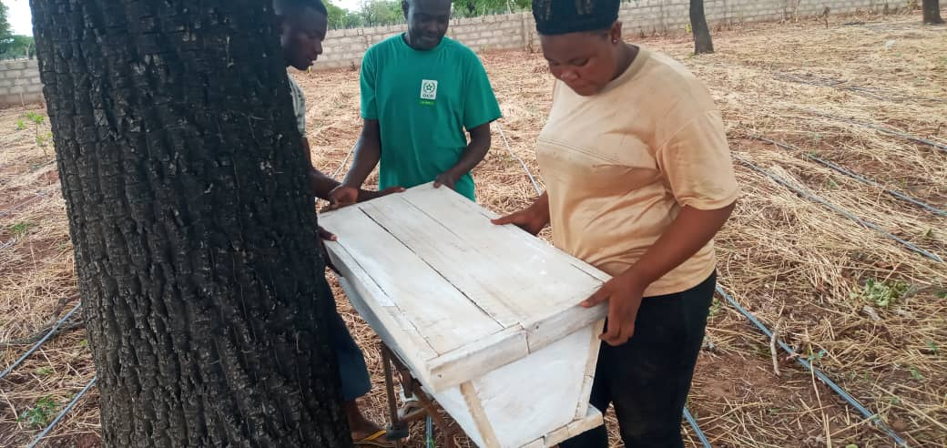
In returned CEAL learned from Solar platform drying systems and Local/ indigenous Seed preservations from LESA. in addition, CEAL also learned from SSL Mobile chicken pens concept which CEAL is already duplicate its modified version her smallholder farmer

Emergency Food AID for the Poor and Affected Households
This activity was aimed at helping poor farmers and their households to overcome hunger in the difficult times. The activity sought to raise funds to procure and supply basic necessities such as staple foodstuff to starving farmer households during the period of food shortages and soaring market prices of food in poor rural communities.
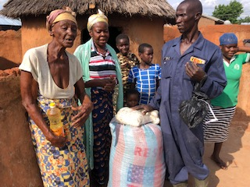
The issue of the food shortages was a spillover from the previous year 2020 farming season where prolong flood waters devastated farmlands and community livelihood supporting systems. The devastating impact of floods and its detrimental long term effects resulting from climate change was being felt harder than before. The situation was made worse with the Soaring food prices and COVID 19 impacts on the local economy, within the shortest time prices of maize had risen from 90ghs a bag in the peak of harvesting to 250ghs/bag in the lean season making it difficult for poor smallholder farmer household to afford. For this reason, a total of 11 communities were selected to benefit from this activity in 2021 farming season.
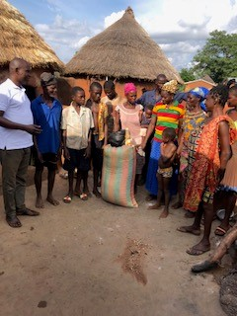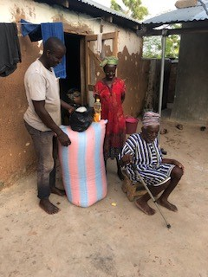
The communities are Kurugu, Kata, Banawa, Gbani, Kpabgu, Nayoku, Kabasi, Boayini, Tinkpanga, Kukuazugu, and Kubori Area. Through GOAP/ELPG support, the activity provided the needed humanitarian aid in the form of Maize, salt and Maggi Condiments/cooking oil to the selected hard hit farmers and their families in CEAL’s operating communities:
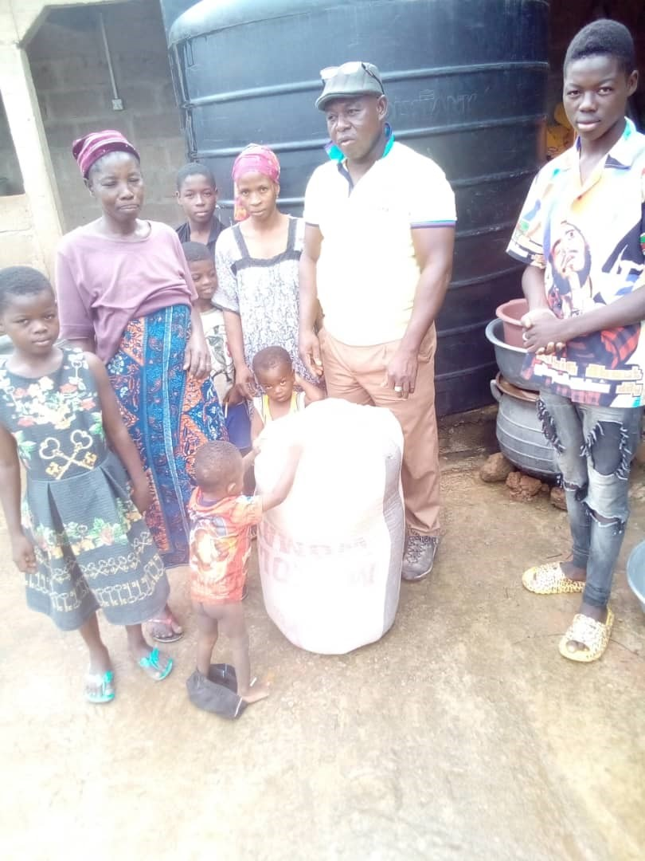
Distribution approach-unlike last year where foodstuff was distributed through the larger community leadership, the distribution of food aid this time was done through household by household in the affected communities. Due to the limited number of food aid items, the approach was simple identified the affected farmer household and serve them direct through household heads. This approach was adopted so as to avoid entire community rushing with the higher tendency of the very needy not ending up getting whiles those who are relatively better end up taken the food away,
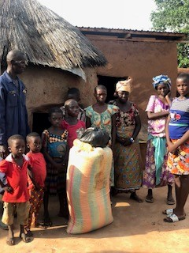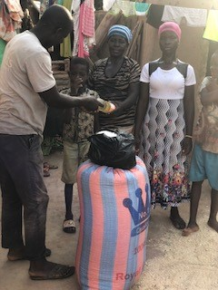
Households headed by females/widows, persons with disability, the sick and very poor were among the basic criteria used to identified and serve the beneficiaries. Each household was given items- 1bag of maize (100kg), cooking oil, salts, and Maggi condiments to enable them manage food shortages in the household until next harvesting. In addition, the beneficiary households were given a little advice on how to plan and manage food and nutrition situation in the household. Through this activity, estimated about 786 individuals benefited-I e with an average household size of 6, a total of over 131 households benefited
GUNDOO PROJECT ACTIVITIES -Under Gundoo, 4 major activities took place in the 2021year under review, these are:
The Sustainable Rice Cultivation and Value Chain Development Activities-rice farming is one of the major activities in kobori Area. The valleys and its flood prone nature makes the area more suitable for rice farming. Therefore to make rice farming a vibrant economic activity in the area, a Small scale rice mills and its accessories have been installed to support smallholder farmers to process their rice so as to reduce post-harvest loses. The equipment adds to complement already install and functioning rice thrasher provided few years ago by GOAP/ELPG. Currently this equipment is of the few that farmers in kobori and surrounding communities are using to thrash and mill their rice grains after harvesting. Over 256(100kg) bags are milled by this equipment, serving, 137 estimated number of farmers in the area. Out of this 55 are male farmers whiles 82 are female farmers. As pro-poor project assistance, farmers are charged very little cost say 10ghs/bag of rice processed as against 12ghs/bags from other rice mills outside Kobori. This money is saved for the purposes of expanding the facility in future and also maintaining the existing one when broken down.
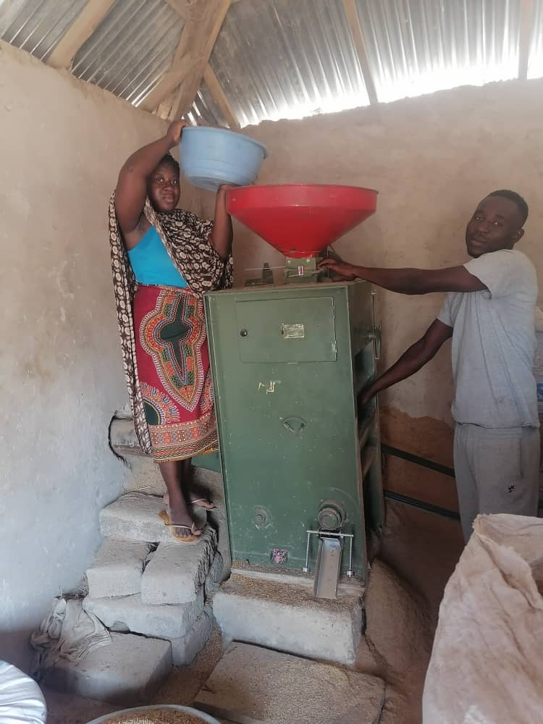
Demonstration plot development-Every year, the key approach of Gundoo project is the use of open fields’ famer schools through demonstration plot to teach and train its beneficiary farmers. This approach has proven to be somehow more effective as they increase farmers understanding through practical experience of the lesson. Therefore the project supported the development of 1 acre of arable land in Kubori to promote organic agriculture farming system. This allowed Gundoo project to showcase organic measures to farmers. It was also used to train farmers in the kobori zone. The demo field development came in the form of land preparation, improved seeds variety mainly maize, manual weed control, training and farmer exchange visits in the area. According Gundoo, estimated farmer population of 46 farmers paid a visit to the field in 2021 under review.
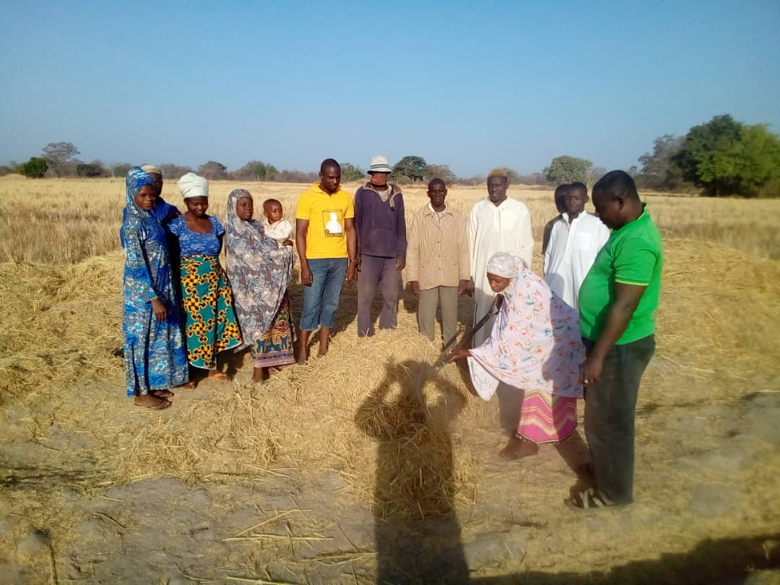
Capacity building in plant nutrition-a total of 46 farmers received training in compost building and application. Out this, 27 are female farmers whiles 19 are male farmers in the Kobori area. Farmers learn how to build compost and were encouraged to build their compost. In addition, these farmers were also trained to prepare and apply farmyard manure in their fields. The compost, manure preparation and application technologies helped the rural poor smallholder farmers to cultivate their rice, and maize in 2021 farming season. In addition few advisory services were provided to rice farmers especially in the areas of land preparation, types of seeds and weed control etc.
The project: SULCi-FaNs: Scaling-Up Local Capacities to Innovate for Food and Nutrition Security (SULCI-FaNS).
This is a summary report covering all activities and results obtained at the year 2021 under review.
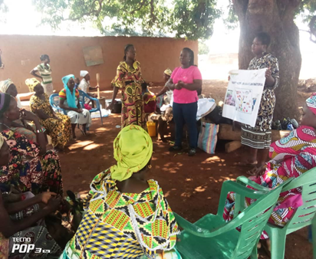
The Scaling up Local Capacities to Innovate for Food and Nutrition Security (SULCI-FaNS) project was designed to strengthen the innovation capacities of rural communities, particularly of women and to increase local resilience to climate change, as well as to contribute to building multi-CP platforms in two sub-regions in Africa – in West and Central Africa and in Eastern and Southern Africa.
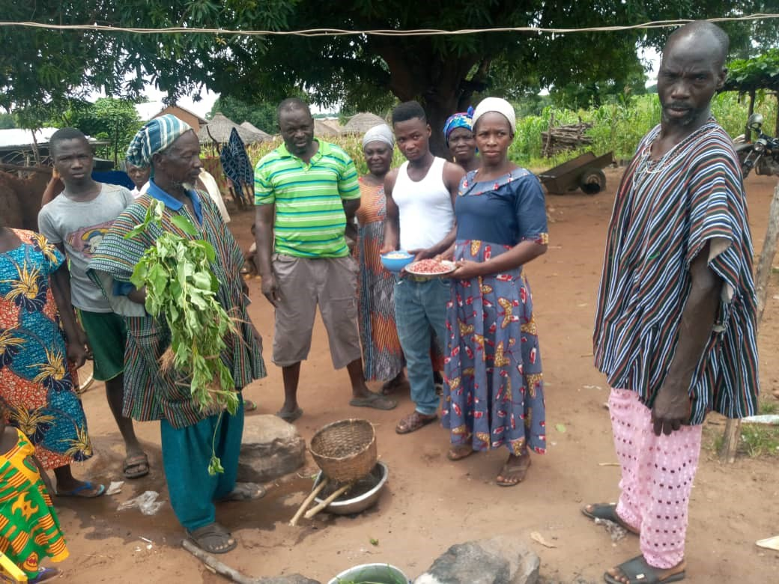
The project took place in four African countries in the Prolinnova network – Burkina Faso, Cameroon, Ghana and Kenya with ACDEP being the project legal holder and coordinator on behalf of the Prolinnova network in Northern Ghana. CEAL participation started 2020 and ended in 2021 as a local NGO implementing activity on the ground in the Walewale Learning Site, Navrongo-Bolgatanga Catholic Diocesan Development Organization (NABOCADO) is the local partner NGO responsible for Bongo learning site. The following activities were planned executed in the year 2021 under review:
Local Innovation Support Funds (Lisf)- this activity made it possible to provide essential inputs through LISF to selected innovators and support them to up-scale their innovations especially the innovation that could not go through full Participatory Innovation Development(PID).
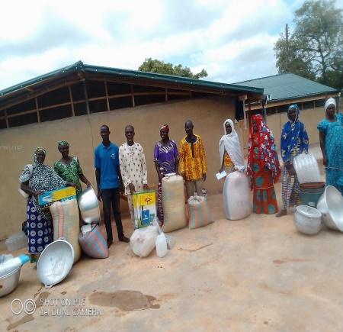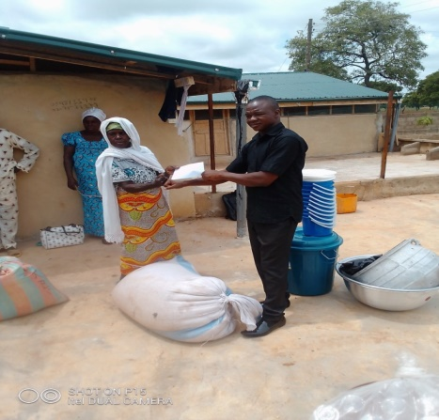
One the key activities executed in 2021 was the establishment of LISF. The fund is aimed at supporting innovators whose innovation cannot go through full PID process to added little value to the current state of their innovations, promote and sell their products for economic incomes. Mr Elijah Adam, chairman of LISF fund committee, together with other committee members discussed, assessed and distributed the funding support. Each innovator needs were assessed, compiled, evaluated and submitted for approval. Support for individual innovator was based on the request made by the individual innovators. After the approval, all input supporting items were acquired by the CEAL team and distributed to beneficiaries at a mini ceremony at the training center. Items include trainings and capacity building, processing and packaging items. A total of 10 innovators were supported in areas of food, nutrition, agriculture, environment and social benefited from this activity. Out of this, 6 were female whiles 4 are male farmer innovators.
PID processes on three Innovations fully conducted and completed. –In all a total of 17 innovations were identified and 3 selected for further development through a farmer- led joint experimentation using PID approaches. The 3 were selected based on their relevance in relation to their direct contribution to Food and nutrition; these are few highlights of the 3 innovations, the PID processes and the results:

PID on Livestock Feed supplement with Madam Issifu Sadia (innovator) and her group- The objective of the activity was to improve the nutritional value and quality of her livestock feed formulation through joint experimentation under Participatory Innovations Development Approach. This activity started with assessment and training of the Innovator –Sadia Issifu and her group on general livestock management process with Dr Avonyo from UDS, Animal Research Department as the main facilitator. This was then followed immediately by the experimentation design using participatory approaches, indicators, feed formulations in 4 categories with participants and their animals.
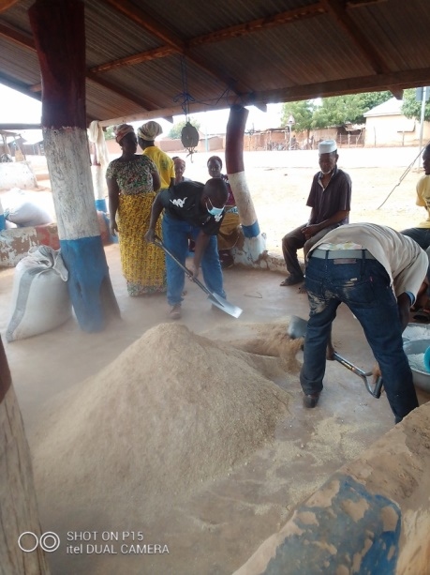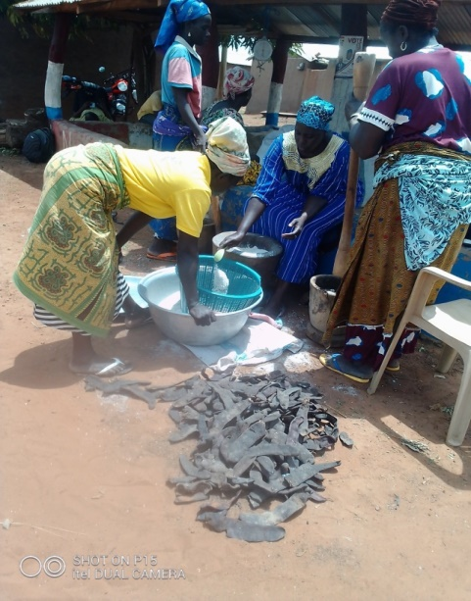
To successfully carry out the experiment, Madam Sadia and her group was divided into four groups. Each group is made up of 3 livestock owners with a minimum number of 4 livestock per farmer making it a total of 12 animals per group. All animals are supposed to be sheep category of livestock before they can qualify for experimentation. This was done to ensure uniformity and to easily provide a common bases to compare results. Out of this 4 categories group, one is controlled and remaining 3 groups are treated with 3 different set of feed with each with specific characteristics of feed formulations from a varying proportion. Ingredients for the mixture of the animal feed were Salt, Salt biter, ba-ama beeri or reticulater, pito mash, salt lick and corn chaff. These ingredients were inspected before the mixture processes began.
Feed supplement formulations for the treatments except for the control
Material | Innovation T1  15% Protein concentrate | T2  15% Protein concentrate | T3  16% Protein concentrate
 | Amount (kg) | Amount (kg) | Amount (kg)
Maize chaff | 14.75 | 14.75 | 14.75
Pitomash | 0 | 0 | 2.26
Piliostigma reticulatum | 6.92 | 6.92 | 6.92
Saltpetre | 0.32 | 0.32 | 0.32
Saltlick | 0.27 | 0.27 | 0.27
Salt | 1.07 | 0.30 | 0.30
Total | 23.33 | 22.6 | 24.82
Cost | GHC87.50/100 kg | GHC82.53/100 kg | GHC80.10/100 kg

The main ingredient in her innovation is Philostigma reticulatum. This plant is a leguminous browse species that has a symbiotic relationship with certain soil bacteria. The bacteria form nodules on the roots and fix atmospheric nitrogen. Some of the nitrogen is utilized by the plant but some can become available to other plants growing nearby. It is a dioecious species, which means that both male and female forms need to be grown together for cross-fertilization and the production of seeds. Both the leaves and bark have medicinal values. The seeds and pods are normally sources of blue and black dyes. According to Abdurrahaman et al. (2017), the nutritional value, antinutritive and mineral compositions of Piliostigma reticulatum pods were within the recommended requirement for ruminant nutrition and therefore recommended to be used as a feedstuff.
To put all animal on the same starting point, each animal received treatment in the form of deworming, vaccinations against major diseases, examined and weigh. This was done to ensure that baseline is established through which changes can be observed and measured as a result of the experimentation.
The following sources of variation namely, the characteristics of the farmer, the sex of animals used in the experiment and the type of treatment was analyzed. Small ruminant weight gains, mortality rates, birth rates, offtake rates, animal numbers, costs, revenues and profits data were all analyzed for differences due to the type of treatment, the management style and characteristics of the experimental farmer and sexes of animals used in the experiment. After 4 months, data collected and its outcomes was shared through community participatory evaluation and validation process. The innovator indicated that her feed was capable of making orphaned lambs survive.
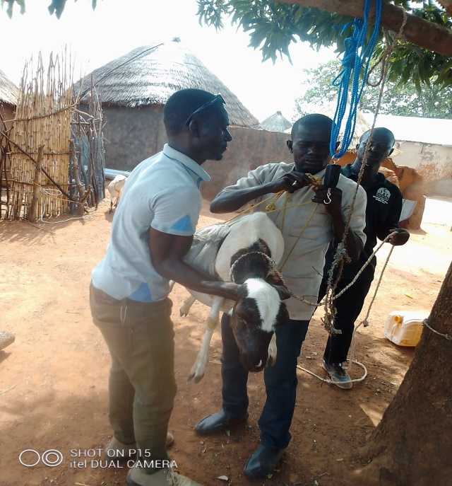
A couple of farmers successfully used the feed to curtail more deaths from occurring in their flocks. The feed improved the body conditions of the animals that consumed it as compared with those without the feed. Moreover, it made lambs look bigger. The results concluded that the feed innovation appeared to be suitable for increasing the productivity and profitability of sheep production. Profit margins may be increased slightly by reducing the salt content of the original innovation and by adding a small amount of sorghum spent grains (pito mash) provided pito mash is available and cheap. As with other technologies, a myriad of other factors were found to affect the profitability of using such an innovation. They included the number of ewes in the flock, their health conditions, their ages, the care provided to the animals, the location of the farmer, perhaps their age and also maybe their sex as in the Ghanaian context, it appears that livestock of male farmers may have more resources at their disposal than those of female farmers.
PID on Biisi Koko (Infant Porridge)-involving Nutrition Experts, Madam Adibuno Apana and her group-
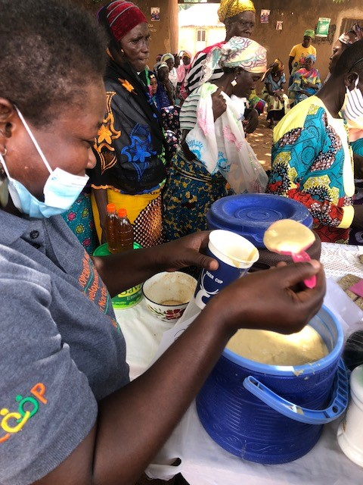
The innovation, preparation of nutritive infant porridge using maize, soybean and fruits by Madam Adibuno Apana was selected after critical scrutiny using the SULCI-FaNS criteria. Meetings were held with the innovator, the focal NGO CEAL, the MSP and technical team from tamale and the community and the PID plans and protocols for the experimentation developed.
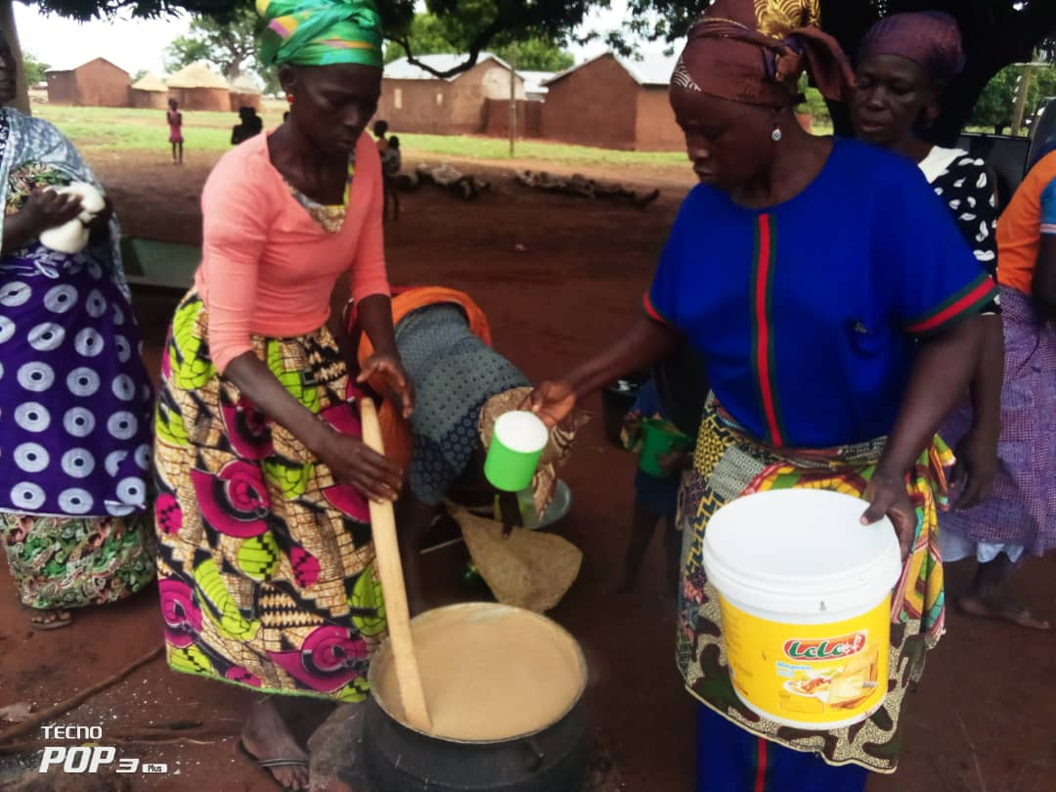
The main aim of the PID was to identify other locally produced cereals to substitute for maize which is the main carbohydrates component with other locally produced cereals such as sorghum, rice and millet without compromising the nutritional quality of the innovation. During the PID planning and protocol design sessions, the innovator and her group deliberated and agreed to experiment on three (3) other cereals recipes from millet, sorghum and rice.
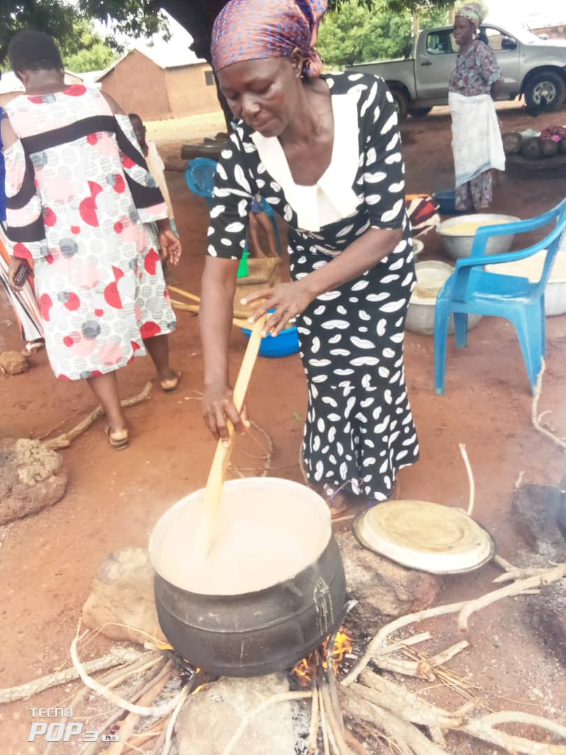
Therefore three (3) infant weanimix porridge recipes with the control (the innovators recipe) were experimented on: A total of 39 females participated in the joint experimentation. The women were divided into four (4) groups and all the four (4) different nutritive infant porridge recipes were prepared. The various recipes were shared and eaten separately at different times. A feedback session was held with the women and they shared how the different infant weanimix porridge dishes were processed and prepared. The women confessed that the various infant weanimix this was confirmed during Participatory Sensory Evaluation carried by the nutrition experts, local MSP members and community member/participants.
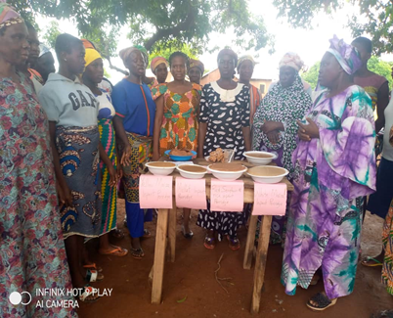
They were divided into male group, female group (youth group and the aged group) to assess the taste, texture, aroma colour / appearance and general satisfaction of the Biikoko flour recipes. Participants were also tasked to evaluate in their view the nutritional content of the different Biisi koko flour, cost, labour and time required in preparing the different Biisi Koko recipes. With this, it became clear that Madam Adibuno Apana Biisi Koko and it’s derivatives are highly nutritious, test well, cheaper to prepare and above all has the potential to eliminate child malnutrition
Walsa PID Experimentation and Evaluation Results-
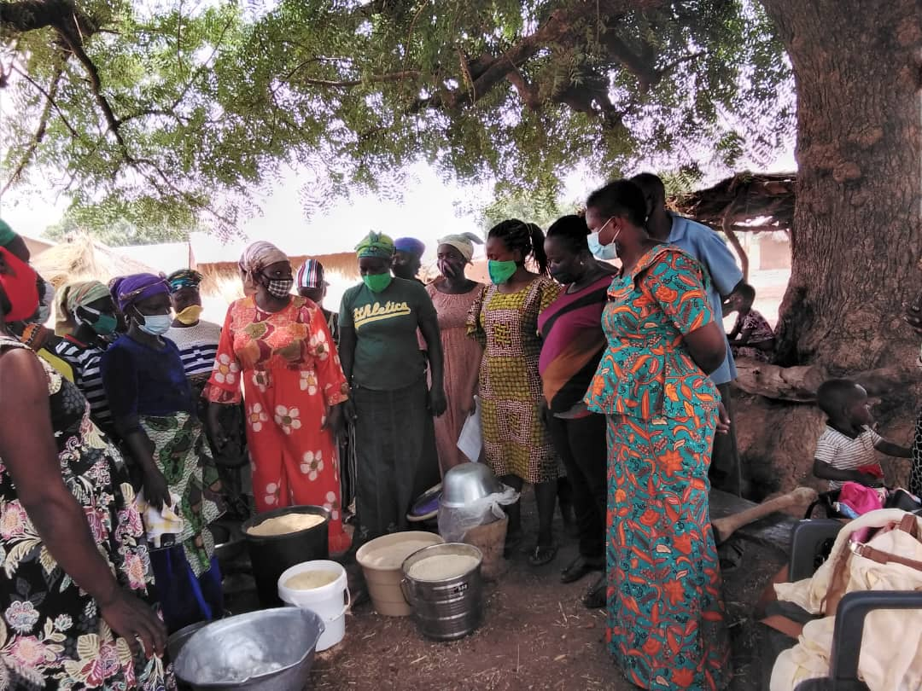
CEAL in collaboration with ACDEP organized nutrition training and participatory innovation development (PID) activities on Walsa, a local but nutritious recipe as part of the SULCI-FaNs activities in Boayini community. The activity was conducted by a team of nutrition experts made up of Madam Naomi, Asana and Juan from MOFA as well as Mr Elijah and Madam Sabratu from CEAL. The participants were Madam Lydia Langah (The innovator) and her group members numbering 26 women. Using participatory approach, the nutrition experts took their turn to inspect all the ingredients/materials for the training before taking participants through the nutrition charts detailing variety of foods and their nutritional combinations/values.
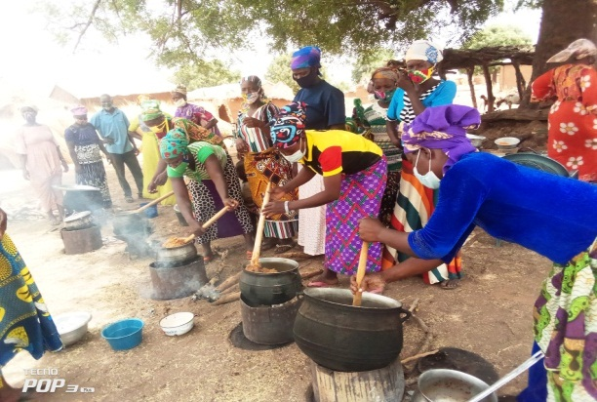
After planning together, 6 different recipes emerged as part of the PID process. All the six (6) different walsa recipes were prepared and the various recipes were shared differently to eat. A feedback session was held with the women about the different walsa dishes they prepared. The women confessed that the various walsa types experimented were delicious and nutritious. The women were encouraged by the nutrition experts to adopt the various flour proportions of the walsa recipes and keep preparing for their family consumption at home. Madam Saburatu, a gender activists and a member of the local MSP encouraged the women not sell their nutritious foodstuff like soybean, yellow maize, millet among others to buy sickness and eat sickness and sell nutritious food stuff to pay hospitals bills but rather eat their nutritious foodstuff to stay healthy always for higher productivity.
The participatory evaluation was carried by the nutrition experts, local MSP members; participants were divided into male group, female group (youth group and the aged group) to assess the taste, texture, aroma colour / appearance and general satisfaction of the walsa recipes. Participants were also tasked to evaluate in their view the nutritional content of the different walsa, cost, labour and time required in preparing the different walsa recipes. All the different groups felt all the different walsa recipes were tasty and nutritious but recipes from the maize, millet and combinations of the millet and other cereals came outstanding. The texture of the walsa was depended on the quantity of water and source fetch aside during the stirring.
3 outstanding innovators shared their innovations through radio discussion-A total of 3 innovators were carefully examined and selected to take part in the radio presentation. The activity took place at Eagle FM, one of the most widely listening local radio Stations in the West Mamprusi Municipality and beyond. The 3 innovators are Madam Sadia Issifu, Lydia Langa, and Mr. Mohammed Wuni, from Gbani, Boayini and Tinguri communities respectfully.
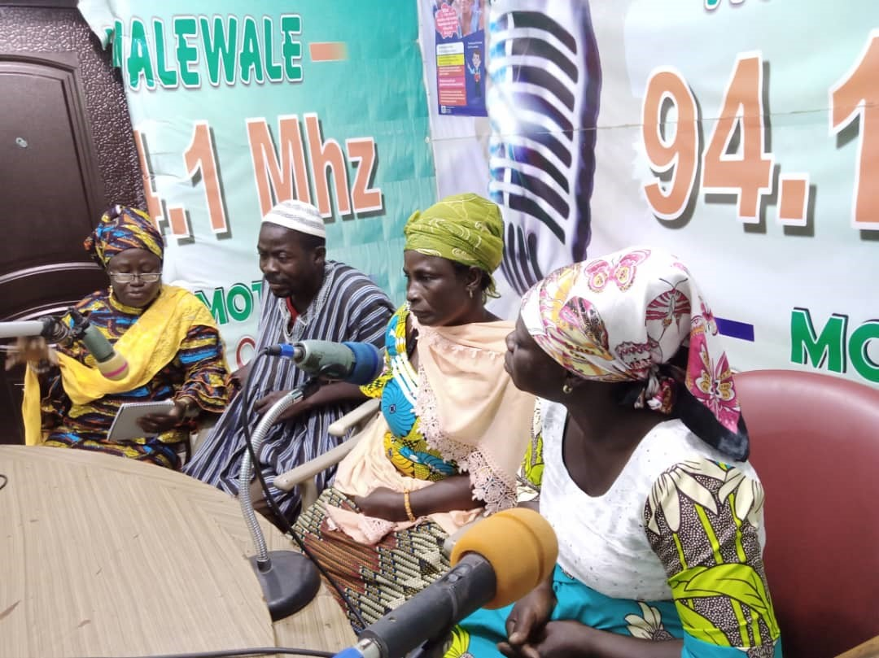
The activity was aimed at sharing and disseminating their innovations to the wider communities for broader adoption and to inspire other farmers to bring forward their innovations in the municipality. It was also aimed at creating the awareness of the project SULCI-FaNs to the larger public in the municipality. The radio broadcast was conducted in local dialect ie Mamprusi Language. Innovators spoke in turns using the following guiding questions: it started with Self-introductions where each member introduced him/herself, where they came from and what they do for livelihood. This was then followed with the Purpose of programme: to share on farmer-led research and innovation approach for sustainable livelihoods-food, nutrition and income security. It then continued with a brief introduction of SULCI-FaNS being implemented in partnership with the ACDEP, using LI / PID approach to empower farmers to improve their food, nutrition and incomes etc. The 3 innovators were then given enough time to tell their stories on their innovations indicating clearly what compelled or motivated them to innovate or research into their innovations, brief description of their innovations and above all what benefits are being derived/ contribution to solving innovators problems as well as impact on others. The activity rounded up with open phone calls where listeners were given the opportunity to ask questions, receives feedbacks and exchange of phone numbers between innovators and farmers in the municipality.

Conducted inter-site exchange visit for innovators and Multi-Stakeholder Platform Members (MSPs) - This is a composite activity report covering two events. That is a visit by Bongo SULCI-FaNs Team to Walewale Site and a Visit by the Walewale SULCI FaNs Team to Bongo Site. The 2 Events basically had the same objectives of promoting, learning, sharing and networking of both teams in order to develop their Local Innovations or take their innovation further to the next level for the purposes of enhancing Income, Food and Nutrition Security in our local communities in the mist of climate change. The activity started with the Bongo Team visiting CEAL operating areas.
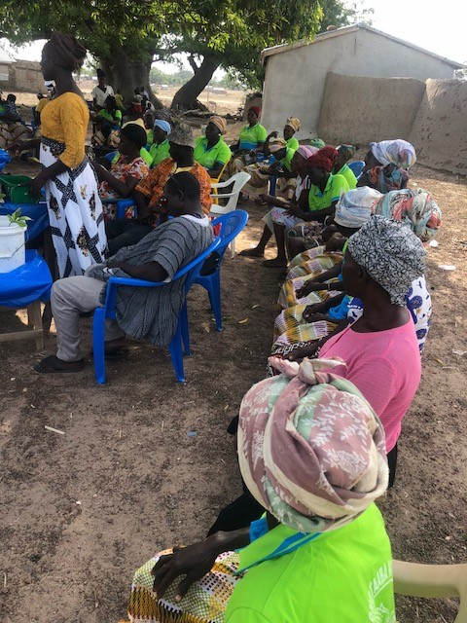
Members of the Bongo team were made up of 11 local Innovators, 2 NABOCADO project implementing team members and 2 MSP members mostly from MOFA. CEAL as the host prepared the grounds in two communities namely Boayini and Gbani communities where the activities took place. A total of 10 innovators from CEAL side were supported to demonstrate and showcase their local innovations and their products. In each community, a durbar was organized for the entire community to enable innovators showcase their innovations. Community members made up of farmers, fisher-folks, traders, women, men, and children took part during the durbar activities. Innovations prepared and showcased their products include Livestock feed formulations, cooking oil extraction technologies mostly from cow milk and sheanuts, organic weedicides and pesticides, local food preparations and fortification, Natural honey making and preparation procedures. Using interactive and participatory approaches, each innovator was given the chance to present to the audience his or her innovations explaining in brief how the idea was conceived, started, process of developing and how he or she managed to get to this stage of her/his innovation development. Visiting team together with community members asked questions for clarifications. Members also contributed to enrich the process by sharing their experience on similar areas of innovations. In returned, CEAL team also paid an equal exchange visit to Bongo Site the following week. The CEAL team was made up 10 innovators, 2 CEAL project implementing members, and 2 MSP members. With similar set up, The Walewale team had the opportunity to witness and see for themselves the innovations from the other side. In an interactive way, innovators from Bongo sites presented their innovations and open up for discussion, questions, comments, learning and sharing from the audiences. The activity ended up successfully with each innovator picking one or two knowledge to improve his innovation relating to food and nutrition.
Other activities
CEAL PARTICIPATED IN COP26-Events Attended, Observations and Results - The summary activity report covers the journey from home town, Walewale to Glasgow to participate in the United Nations Framework Convention on Climate Change (UNFCCC) –COP 26 summit.
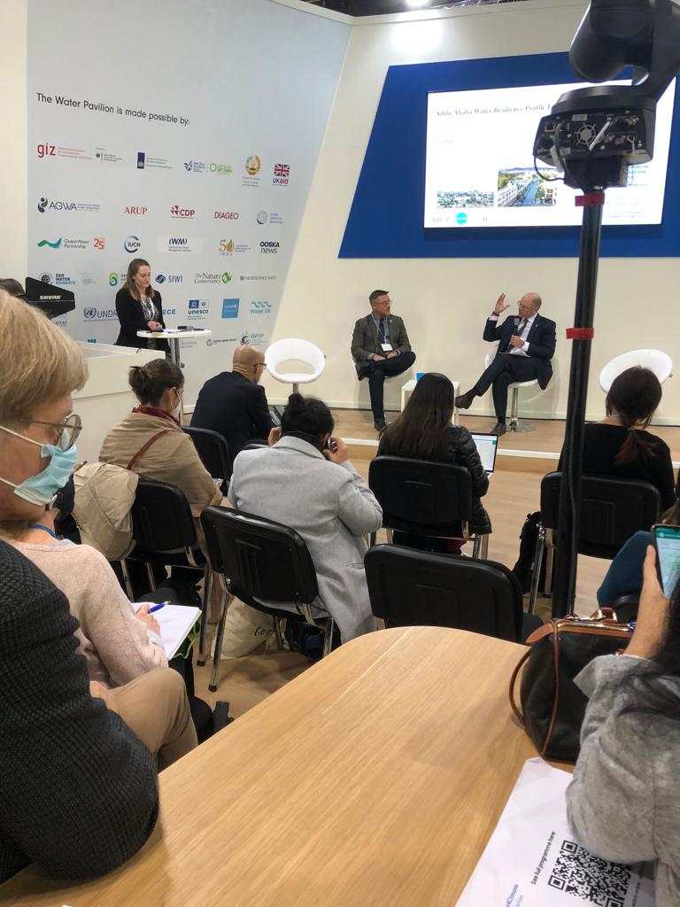
The aim of the COP26 summit, we were told is to give world leader the platform to negotiate and commit themselves to keeping the global average temperatures within acceptable limit. As a participant under the status Observer, the aim of my participation wa to observe, listen, and participate in events with some constructive suggestions. Others include networking, learning and sharing ideas that can be replicated in our communities’ in relation to climate change mitigation and adaptation. CEAL Team Leader participated on behalf of CEAL. A total of 8 side events and one plenary session were attended by CEAL Team Leader (TL). The following are few highlights:
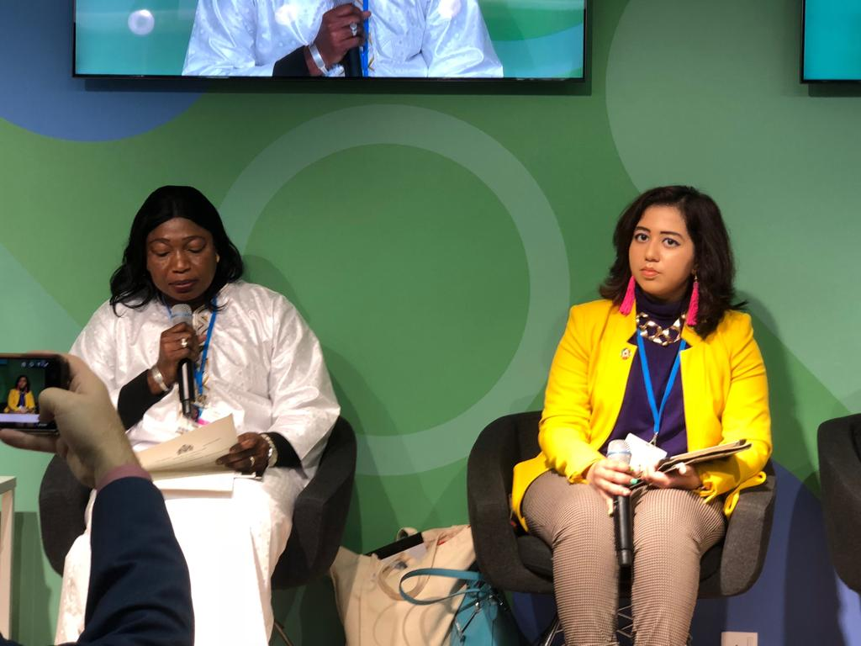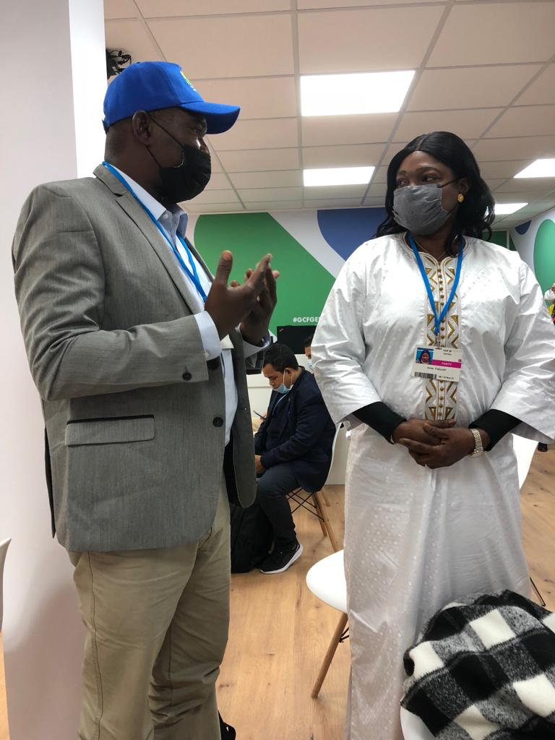
UK media/development aid group (Republica Media)- my colleague Hayad from Djibouti and I had engagement with this group through Zoon link. The group wanted to hear from us, what we do in relation to climate change, which network we belong to, why we are participating in the climate change conference in Glasgow and what can they do to support our work in our various countries . It was a nice discussion but in brief, where each of us (Hayad and Issifu) took turns to tell the story about what we do as individual organizations in our different country. We also had a chance to tell them what RSN-Africa is all about and who supports us, our observation in the summit, expectations on our Africa leaders and demanded from them what they could do to support our works in our various countries. All our Africa leaders don’t have any message apart from bring the adaptation monies that you developed countries promised, our Africa leaders didn’t bring anything to the table, all they say is bring the money,…bring the money but no one is telling us in case the money promised by the richer countries are not coming what is next plan of action –a statement according to Hayad during one of plenary session.
Sustainable food systems: the role of Rio convention on biodiversity, climate change and desertification –this was a side event activity organized by Global Environment Facility and Green climate Fund. The activity brought expert panellist together to discuss ways that our current food production system could be done in a more sustainable manner in the mist of climate change impacts. Concentration was more on developing countries especial sub-Sahara Africa countries. Critical was our current food production value chain models, its strengths and weakness, impacts of climate change, drought and desertification, land limitation and its ramifications especially to vulnerable women, underground water exploitation, the financial mechanism available to support food production system and what Africa leaders are doing to address these challenges amidst climate change impact.
Green Climate Fund (GCF)-independent evaluation report- under this activity, panellist discussed challenges confronting countries, agencies, civil society groups and financial institutions ability to accesses the funds for adaption and mitigation purposes. Key challenges include design challenges, capacity challenges, macroeconomics challenges and delays challenges. Issues include vigorous application process including cumbersome call for proposals guidelines, duration for feedbacks and above all counterpart funding commitment from poorer entities with good mitigation and adaptation concepts but cannot provide the counterpart funds. Relevant to me as small group and also local CSO was how smaller groups and CSOs can like CEAL be able to access the funding given the current cumbersome process. This was finally recommended and accepted, after I posed the question, that a small grant program with simple call for project proposal procedure be designed as part of their broad program implementation. This is something I think if implemented will benefit not only RSN members alone but all local CSOs in Africa and beyond.

Possible Clear benefits of the participation:
- Learning and sharing: CEAL had the chance to learn from others and also share our works with other participants in the areas of climate change adaption and mitigation measures. It presented CEAL the unique opportunity to exchange ideas. Some of these ideas will eventually become our future projects.
- Exposure: through this participation, CEAL is gradually becoming visible in the eyes of many individuals and organizations in the global stage. I had the opportunity to meet a lot of people both big and common guys to sell our brand. What we do, our little contribution to climate adaption and mitigation efforts. Some of them have already started contacting us.
- Connecting and networking-through this participation, CEAL made a lot of contacts and networked with organizations. E.g. CEAL is on his way to become a network member of many network organizations. I received email from Nordic facilitator discussing possibilities and how CEAL could benefit from Nordic network activities in the near future.

CEAL PARTICIPATION IN GGS-GHANA DELEGATION TO KENYA- during the year under review, a member of CEAL in the name of Sadia Wuntima Yakubu, gender and technical advisor traveled with a team of four persons to Kenya in November, 2021. The PGS-Ghana team was made up of two females and two males. They are Anthony Dotey, vice president of PGS Ghana, Olawumi Benedict coordinator of PGS Ghana and also doubled as the founder and C.E.O of Grow West Africa, Othniel Fosu Boateng as the Ashanti regional representative of PGS-Ghana and also C.E.O of Green Shed farm. The travelled team mission was to share Ghana experience and also under study the Kenyan organic farming practices, system and then return to implement some aspects that are applicable to PGS Ghana, share what they learned with larger PGS-Ghana networks as well as the various individual organizations. Whiles in Kenya, the team made a visit to keserian County, where they visited Gad-eden Green House and Nursery, Community Sustainable Agriculture and Healthy Environmental Program (CSHEP), Silvia's Organic Farm And Silvia's Basket (Organic Vegetable Shop) Both In Limuru And Ngong Road respectively for information visit .www.sylviasbasket.co.ke,
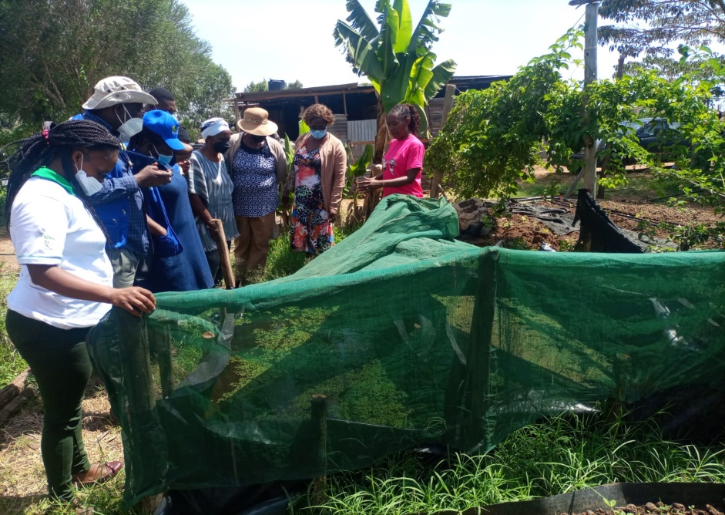
Peter's Organics, Participatory Ecological Land Use Management (PELUM) Kenya and Grow Bio Intensive Agriculture Center Kenya (G-BIACK) Thika Kenya among other farms with more information website:www.G-BIACK.org. in Kenya the Ghanaian Team learned from their Kenyan counterparts the following:
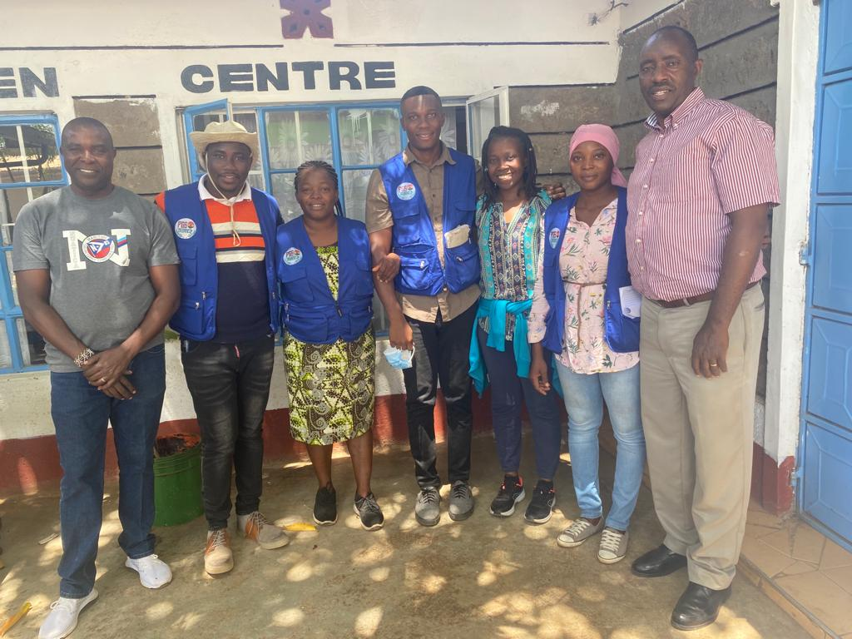
Compositing or organic fertilizer preparation and application, Verme composting, Black soldier fly production,Green manuring, Azollah production, Pest managing and disease control, Forlia fertilizer (organic) preparation and application,, Organic livestock and poultry medication using herbs, Fodder preparation, How to rear organic diary cows and goats, Planting method e.g seed and cutting, Their marketing strategies marketing, Financial record keeping, Post-harvest handling and processing of crops e.g charcoal cooler, solar drying, and fermentation. Others include Their agro ecological principles , Packing of their vegetables, How trainings are done for interested youth and already existing farmers e.g farm walk training, practical, How climate change affects farmers and how they are adapting to those changes e.g improved in drought tolerant seed varieties, Harvesting techniques, Mulching, Irrigation and water Management, How to control weeds, How to promote indigenous Vegetable production , How to store seeds, Value addition to their farm produce e.g potatoes and cassava creeps, juices and Organic farmers group constitution. The Ghanaian team in return also shared with their Kenyan counterparts How to prepare a mould for planting cassava and How to process gari using cassava and cassava flour
Pro-Eco Africa Organic Research Results Dissemination: -As part of the 2021 activities, CEAL participated in research results dissemination workshop orgainzed by Pro-Eco Africa and MOFA in Ghana. The workshop was aimed at sharing and discussing with stakeholders the results of ProEco Organic research commissined in 2012 and completed in 2020. The worship took place in Accra-Ghana under the heading: National Dessinmiation And Policy Dialoque Worshop-Productivity, Profitability And Sustainability Of Organic Farming In Ghana. Series of power point presentations were made including key highlights of project findings such as organic contribution to food security, generate considerable incomes to farmers, improvement to the environment etc. the findings report however pointed out that more knoweldge and skill in organic farming are needed, livestock integration, post harvest losses are equally some of the areas that needs attention if stakeholder wants to grow the organic sector.
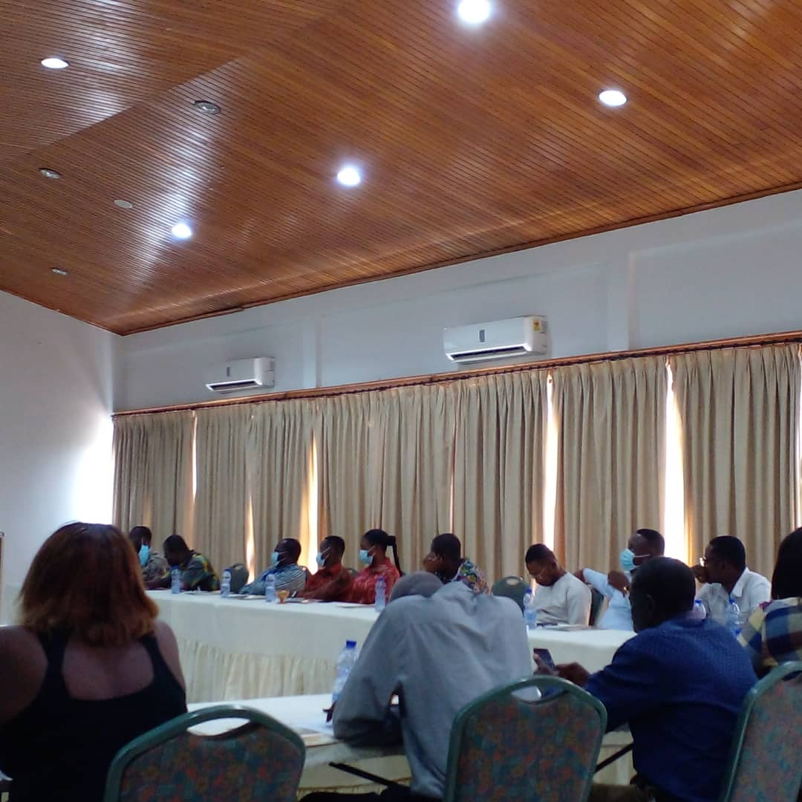
Other important areas tourched include organic farm inputs supply and accessibility, premium prices and farming records
Pwalugu Multipurpose Dam-currently a multi-purpose dam is being constructed along the White Volta River with specific location in Kurugu near Pwalugu in between West Mmaprusi Municipal and Talinsi District. The purpose of the Dam is to provide drinking water to selected communities, irrigate 20,000 hectares of arable lands downstream and finally produce about 50-100MGW of electricity to the national grideline. The contruction began last yaer by Sino-Hydro, a company from China but with a number of issues. It is for this reasons that this forum was organized to seek stakeholder inputs through consultations. The forum was organized by TAMA foundation Universal, a Civil Society Organization based in Tamele in collaboration with Oxfam –Ghana. In his reopening remarks said this forum sought to deepened consultation on the Envirobnmental and Social Impact Assessment Reports, matter arrising and possibles suggetions, according to Dr Chairle Abugri, one the organizing member of the forum. The forum which took place in Bolgatanga in the Upper East Region brought together stakeholders from different background such farmers, researchers, academia, traders, CSOs, Chieves, Local Authorities, Queen Mothers, Youth Groups and Associations, Volta River Authority, Land Owners, etc. Key speakers are Prof. David Miller of Open University, Prof. Agness Apusiga of University Of Development Studies, and Dr Chairles Abugri. Presentations about the history of the Dam from the Drawing board to the current physical construction, the engineering features, the impacts of the Dam in relation to floods coverage, displaced communities, farmlands, and issues of compensations were covered. Stakeholders discussed the Dam Designed, the ongoing contrustion, culculable flood areas and those to be affacted, fairness and equity in the benefit sharing accruing from the dam ie drinking waters, electricity and irrigation lands distribution among the different ethinic or tribes in the Dam catchment area
Ecological Organic Agriculture Platform –Ghana (EOAP)-CEAL participated in the Annual General Meeting(AGM) organized by EOAP-G. The meeting came in the form of zoom due to COVID 19 restriction. The meeting was made up of network members of ghana organic and ecological agricultural practitioners which include farmers, researchers, academia, traders, organic inputs dealers etc. The purpose of the meeting was to review the performance of the platform in the year 2021 and to elect new leadership to take the movement forward. Executives in the meeting gave their accounts about how much funds were raised over the past, how much money is spent, areas of the expenditures, activities executed and plans for the next year 2022. In the end, new excutives were also elected in which a member of CEAL in the name Issifu Sulemana, CEAL Team Leader took the position of National Vice Chairperson. With this position, its expected that CEAL and her community smallholder farmers are able to influence and contribute strongly to national policy in relation to organic farming in Ghana
Participatory Guarantee Systems (PGS)-Capacity Building workshop- PGS –Ghana -Training of trainers (TOT)- one person from CEAL in the name of Sadia Wuntima Yakubu received training in solar drier construction. The capacity building workshop was organized by PGS-Ghana with funding support from GIZ and WindRock-USAID Feed the Future program.
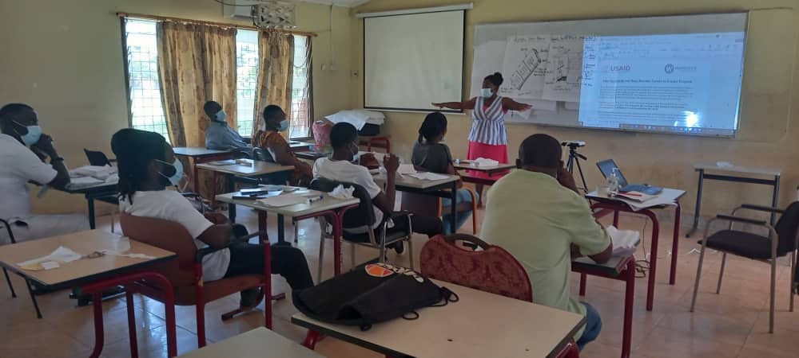
The workshop brought together one participant from each 16 regions in Ghana to be trained as regional trainers.
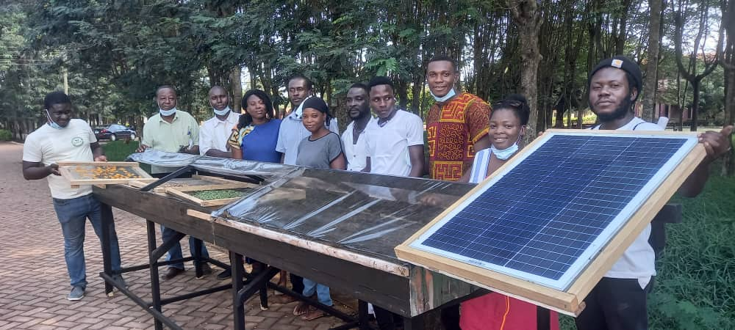
The one person trained had a responsibility of training as many farmers as possible in their respective regions. Basically they were taken through how to construct different types of solar drier
Global Environment Facility (UNDP GEF-SGP)-one workshop was organized during the year 2021 by GEF-SGP for all GEF stakeholder network to learn and share results and experience on GEF supported micro projects implementations. The workshop took place in Wenchi in the Bono Region of Ghana. CEAL made a presentation on the results of South-South Cooperation Project -Replicating and Promoting Broader Adoption of Innovative Climate-Smart Agroecology within Community Landscapes in Ghana, Liberia, And Sierra Leone. key results were shared with participants, and also learn from them some of the agro-ecology activities undertaken.
CEAL participation in Local fundraising workshop-two person from CEAL participated in Local Fundraising workshop. The workshop took place in Kumasi in the Ashanti Region of Ghana was organized by West Africa Civil Society Coalition Network with funding support from wildgees- Netherlands. The purpose of the workshop was to equip participants with skills and knowledge in local fundraising i.e. improving medium to long term fundraising capabilities focusing on local to national potential donors just to complement the existing foreign donor inflows. The targeted potential local donors include individuals, local businesses, companies and relevant government agencies operating within the country or CEAL operating localities Local fundraising has never been part of CEAL focus. Although over the past years very vital CEAL activities has been benefiting from local resources mostly in-kind but never took stock of them as local fund-raising.
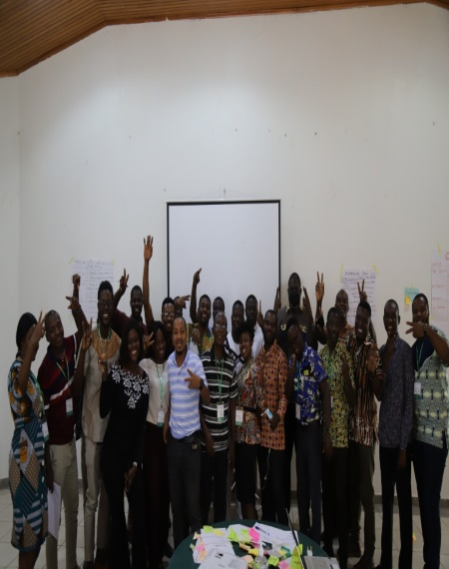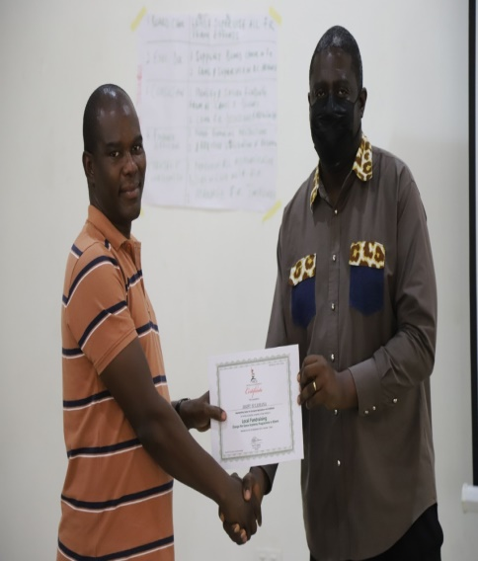
With this workshop, few skills and techniques in local fundraising such as friend-raising, Solicitation, and Personal Selling have been learned and would be used to generate addition funds to support CEAL activities on the ground. The training ended with each person awarded with a certificate of participation
Advisory Board Meetings- As part of 2021 activities, CEAL advisory board members met two times during the year under review. The first and second meeting brought together all the members of the 5 advisory board to discuss among other things work plans, budgets, progress of work so far, activities executed during the 2021, funds raised, the expenditures and the finances including 2020 audited reports. In addition, results of activities, achievement, lessons and challenges were also discussed and some few recommendations given for management to implement.
Management meetings - 3 meetings were organized at the beginning, middle and end of the year during 2021 year under review.
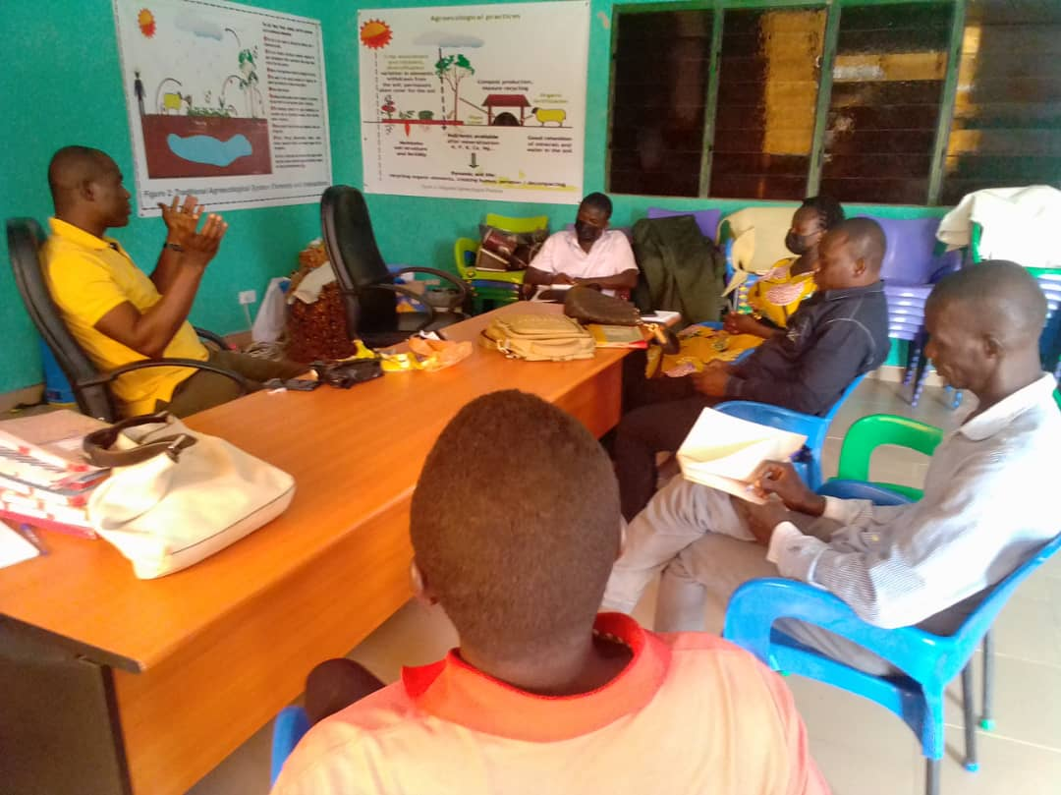
The 1st meeting was organized to discuss and plan for the execution of the quarter by quarter activities. The 2nd meeting was organized to review progress, and make adjustment whiles the 3rd meeting was organized to review, compile reports and conclude on the next year 1st quarter activities. It was attended by the CEAL project implementing staff

Major Challenge-COVID 19-despit the reduction of restriction, the COVID 19 impacts still placed overwhelming financial and psychological stress on smallholder farmer in the northern Ghana. Farmers are still trying to get labor and some critical inputs necessary for the smallholder to produce for household consumption and also income to cater for household needs

Also, heavy rainfall made drilling of boreholes very difficult as the drilling vehicle could not easily moved round especially in remote communities to drill causing unnecessary delays in the year activities. In many instance the vehicle got stacked for several day because of heavy downpour.
Conclusion: the year 2021 is gone with remarkable results. With a results of 4900 plus, we can comfortably say that we are almost half way of the 11000 smallholder farmer target set to achieve under the Farmer 2 farmers approach. In the years ahead, CEAL will be working her hardworking smallholder farmers both men and women, youth and old to achieve the 11,000 smallholder farmer target set through F2F. We are not there yet. But with the support of all our development partners surly and gradually we hope to be there and will be there. This is what this boy from Walewale-Kukuazugu is saying
